NETWORK STATEMENT
2020

Table of contents
- GENERAL INFORMATION 8
1.1. Introduction 8
1.2. Purpose 10
1.3. Legal framework 10
1.4. Legal status 10
1.4.1. Liability 10
1.4.2. Appeals procedure 11
1.5. Structure of Network Statement 11
1.6. Validity and updating process 11
1.7. Announcement 12
1.8. Contacts 12
1.9. International cooperation among infrastructure managers 12
- CONDITIONS FOR ACCESS TO RAILWAY INFRASTRUCTURE 13
2.1. General conditions of access 13
2.1.1. Conditions for submission of requests for train path allocation 13
2.1.2. Railway transport services 14
2.1.3. Certificate of safety and License for transport 14
2.1.4. Railway infrastructure access contract 14
2.1.5. Framework agreement 15
2.1.6. Liability certificate – insurance 15
2.2. Transport of special consignment 15
2.3. Transport of dangerous goods 16
2.4. Rolling stock acceptance procedure 16
2.5. Staff acceptance procedure 17
- INFRASTRUCTURE 18
3.1. An extent of network 18
3.1.1. Borders 18
3.1.2. Adjacent railway networks 19
3.1.3. Industry tracks 19
3.2. Network description 19
3.3. Technical standard of ŢŽICG network 20
3.4. Traffic regulation system and communication systems 20
3.5. Telecommunication system 20
3.6. Auto- Stop devices 20
3.7. Traffic restrictions 20
3.8. Availability of infrastructure 21
3.9. Official places for reception and dispatching of passengers 21
3.10. Official places for loading and unloading of accompanied cars 21
3.11. Manipulating places 21

3.12. Technical facilities for service provision 22
3.12.1. Marshalling yard 22
3.12.2. Side tracking tracks 22
3.12.3. Freight car scales and loading gauge meter 22
3.12.4. Ramps for loading and unloading of freight 23
3.13. Development designs for infrastructure 23
- CAPACITY ALLOCATION 24
4.1. Procedure description 24
4.1.1. The method of capacity allocation 25
4.1.2. Competent bodies involved in capacity allocation procedure and their responsibilit 25
4.2. Time Schedule for path request and capacity allocation 25
4.2.1. Time Schedule for application for annual timetable 26
4.2.2. Plan of application for capacity allocation without procedure for forming annual
timetable (Ad hoc) 27
4.2.3. Capacity allocation in the course of valid timetable for shorter time of service
provision, taking into account regular amendments of annual timetable 27
4.3. Allocation process of capacities 28
4.3.1. Adjustment procedure 28
4.3.2. Settlement dispute procedure 29
4.3.3. Congested infrastructure 30
4.4. Allocation of capacities for trains for maintenance and reconstruction 30
4.5. Allocation of capacities for the usage of service facilities 31
4.6. Non usage paths/ Cancellation rules 32
4.7. Exceptional transport and dangerous goods 32
4.8. Transport of dangerous substances 33
4.9. Special measures in the case of disturbances 33
- SERVICES 34
5.1. Minimum access package of services 34
5.2. Track access to service facilities and their usage 35
5.3. Additional services 37
5.4. Ancillary services 37
5.5. Services of operator 37
5.6. services of maintenance 37
- CHARGE 38
6.1. Method of charging 39
6.1.1. Minimum access package 39
> Weighting coefficient ( ) 39
> Track wearing coefficient ( ) 39
> Factor expressing carrier`s requirements regarding timetable ( ) 39

> Factor of influence of special consignment to price of train path where spatial
consignment is transported (Fnp) 39
> Length of train path(Q vkm) 39
> Price for train kilometers ( Cvkm) 39
6.1.2. Tracks access to service facilities and their use 40
Side tracking tracks 40
6.1.3. Additional services 41
6.1.4. Accompanied services 41
6.2. Train path revocation or planned drive 41
6.2.1. Train path revocation 41
6.2.2. Cancellation of planned drive 42
6.3. Train path change 42
6.4. Price change 42
6.5. System of transport quality indicators 42
6.6. Exceptions to usage charging 43
6.7. Method of payment 43
6.8. Payment insurance 44
ANNEXES 45

Terms used in Network Statement:

Term | Meaning
Ad –hoc request | Request for a infrastructure capacity allocation requiring train path  allocation for annual timetable
Industrial track | Railway track to be connected to the infrastructure and serves for delivery and dispatch of goods to the owner or holder of rights to use that track.
Public transport | Transport of passengers and / or cargo, which is available to all users on equal terms
Infrastructure capacity | Total number of train routes allowed by the infrastructure on a given line section, for the present timetable
Licence for transport | Document that certifies the right to make all or special kind of transport in railway transportation
Licence for railway infrastructure management | Document that certifies the right to manage the infrastructure
Freight terminal | All official spots opened for freight reception and parcel dispatching
One Stop Shop | Representative of Infrastructure Manager jointly with representatives of other infrastructure managers make international network facilitating access to international railway infrastructure for customers.
Access right | Right of rail transporter to use railway infrastructure
Transport of passengers of public interest | Transport which provides transportation services to meet the socio-economic needs in a non-discriminatory basis and continuously
Timetable | Infrastructure Manager’ s act that defines plan of train operation
Certifikcate on safety for transport | Documents on the fulfillment of conditions for the safe operation of rail transport
Certificate on safety for infrastracture management | Document on the fulfillment of conditions for the safe management of infrastructure
Train path | Infrastructure capacity needed to train operation between two official places, at certain times, and under precisely defined technical and technological conditions on the infrastructure
Contract on the use of infrastructure | The contract governing the mutual rights and obligations between infrastructure managers and railway carrier
Infrastructure Manager | The legal entity managing the infrastructure
Bottlenecks | A part of infrastructure that cannot fully meet requirements for infrastructure capacity, not even after coordination of various requirements for capacities
Rail carrier | The legal entity performing public transport of passengers or transport for their own needs in the railway transport, which provides traction trains or the provision of train traction services only.

Abbrevations used in the Network Statement :

Abbrevations | Meaning
CRPS | Central register of business entities
FTE | European organisation of railway transpoerters (Forum Train Europe)
GIŠ | top of rail
KM | Overhead contact line
MC | AD MONTECARGO Podgorica
OSS | One Stop Shop
OŽVS | Joint Stock company Rolling stock maintenance Podgorica
RID | Regulation for international railway transport of dangerous good
RNE | Association of european railway infrastructure managers (Rail Net Europe)
TK | Remote control
UI | Infrastructure Manager
UIC | International Railway Union
ŽICG | Railway infrastructure of Montenegro Joint Stock company Podgorica
ŽP | Railway transporter
ŽPCG | Railway transportation of montenegro JSC. Podgorica

1. GENERAL INFORMATION 1.1. Introduction
In accordance with the Strategy of the Government of Montenegro to restructure Railways of Montenegro, an extraordinary General Meeting of Shareholders of Ţeljeznice Crne Gore ADPodgorica, at the meeting held on 02.07.2008, adopted the Decision on the restructuring of Ţeljeznice Crne Gore-Infrastruktura-DOO, Podgorica into Željeznička Infrastruktura Crne Gore AD-Podgorica(Railway infrastructure of Montenegro Jsc.-Podgorica)
Željeznička Infrastruktura Crne Gore AD-Podgorica /hereinafter ŽICG/ is railway infrastructure manager in Montenegro, acting as legal entity and within its scope of work, independently, in legal transactions, deals with legal affairs and undertakes other legal actions of importance for business. On the 9th of July 2008, in Central Register of Commercial Court in Podgorica has been registered: ŽELJEZNIČKA INFRASTRUKTURA CRNE GORE AD-PODGORICA, under registration number 4-0008771/001, as Joint Stock Company
Railway infrastructure of Montenegro, excluding industry tracks, is a public property in general use, owned by State and available for use under equal conditions to all interested transport companies as it is prescribed by Railway Law.
Railway infrastructure management is an activity of general interest. Infrastructure management,
in terms of the Railway Law, includes: maintenance of infrastructure, organization and
management of railway transport, modernisation of infrastructure and protection of infrastructure
ŽICG manages railway network of 327,72 km.
In compliance with Railway Law, Network Statement includes:
- review of the infrastructure characteristics which is available to applicants;
- requirements for the allocation of infrastructure capacity;
- the procedures and criteria for the allocation of infrastructure capacity;
- criteria for determining the costs and charges for use of infrastructure;
- procedures under load of infrastructure and
- other information relevant to the allocation of infrastructure capacity.

Organization chart of ŽICG

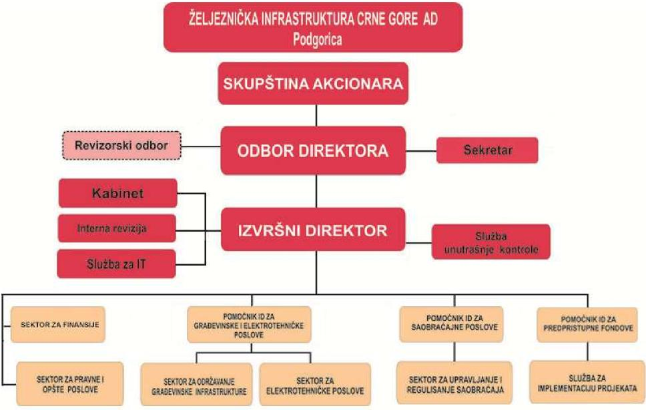
Organization of railway sector in MNE
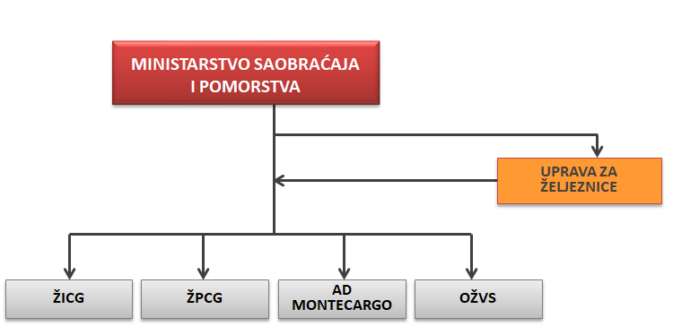

1.2. The purpose
The purpose of this Network Statement is to provide single source of essential information that will be required by railway undertakings wishing to operate train services on railway infrastructure managed by ŽICG.
The Network Statement is a document of infrastructure manager detailing the available infrastructure, designed for operators who apply for the allocation of infrastructure capacity (The form is provided in Appendix 1a).
1.3. Legal framework
The functioning of railway infrastructure and traffic on the railway network of ŽICG has been regulated by legal act of Montenegro, Infrastructure Managers Acts and acts and technological procedures of Transporter. Rail carrier, in its performance of transport services, must comply with all the legal rules contained in international sources of law as well as national laws and regulations. Regulations and procedures relating to carriers in Montenegro have been defined by the Ministry of Transport and Maritime Affairs in collaboration with the Administration of Railways and ŽICG.
During drafting of this document were used recommendations and directives of EU.
In Annex 1c is enclosed a list of European regulations, national laws, regulations and ordinances that are mentioned in the document and that are used in drafting the Network Statement.
1.4. Legal status
The Network Statement is primarily used as a source of information for train operators. Contract on the use of railway infrastructure that conclude the infrastructure manager and train operator may refer to specific parts of the Network Statement , thus binding parties.
ŽICG on the basis of the Railway Act shall be obliged to adopt each year and publish network statement, updated regularly and if necessary changed.
The Network Statement is published on the website ŽICG, www.zicg.me in the montenegrin and english language. If there is no matching between montenegrin and english version, the relevant is montenegrin version
1.4.1. Liability
ŽICG is responsible for the regularity of information of the Network Statement, but it is not responsible for the detriment caused by printing mistakes in the Network Statement.
Network Statement is elaborated according to information available up to 01.01.2019. In the case of disparity of Network Statement with valid legislation, valid legislation is applied . Legislation being in the process of preparation while drafting Network Statement, is not taken into consideration. All regulations and technical documents entrying into force upon publishing of

this Network Statement shall be applied and shoudl be taken into consideration during interpretation of this Network Statement.
1.4.2. Appeals procedure
Rail carrier may submit appeal to the Administration for railways in the moment when it considers that, in relation to other applicants for infrastructure capacity allocatio, he is treated unequally/discriminatory/ or in any other way suffer damage in relation to the Network Statement, including:
- criteria that it sets,
- procedure for allocation of capacity of railway infrastructure and its results,
- criteria for infrastructure access fees,
- level and structure of price for infrastructure access,
- other cases with regard to assurance of access and infrastructure capacity use.
Applicant can regarding this Network Statement initiate procedure for legal protection. He may also submit an appeal to the decision of ŽICG on Amendments to the Network Statement.
Starting procedure of legal protection does not influence on the delay of the entry into force of the Network Statement .
1.5. Structure of Network Statement
This Network Statement is elaborated in accordance with the structure of the Network Statement adopted within international organisation the RaiNetEurope(RNE), Aassociation of European Rail Infrastructure Managers / www.rne.eu /. Adopted structure of Network Statement ensures that Network Statement of different infrastructure managers from different countries shall be uniform and contain roughly the same information
Structure of the Network Statement
No. | Network  Statement  chapter | Content (description ) of the chapter
 | General information | contains objectives of issuing Network Statement
 | Access conditions | sets conditions that rail carrier should meet in order to access to railway infrastructure
 | Infrastructure | contains description of railway infrastructure managed by ŽICG
 | Capacity allocation | sets procedures and conditions for infrastructure capacity  allocation
 | Services | contains description of services provided by ŽICG
 | Charges | contains description of method for calculation of infrastructure access charge and services provided by ŽICG.

1.6. Validity and updating process
Network Statement is valid for the period of annual timetable.
This Network Statement is related to ::
• access to railway infrastructure and use of railway infrastructure for the validity of timetable 2019/2020,
• procedure for infrastructure capacity allocation for timetable 2019/2020.
Timetable 2019/2020 enters into force on the 15th of December 2019, and ends on the 12th of December 2020.
ŽICG must regularly update Network Statement in the case of changes of important information that have been issued. All changes of Network Statement shall be announced on website www.zicg.me .
ŽICG shall inform about making changes rail carrier with whom has concluded contract on railway infrastructure use . .
1.7. Announcement
The Network Statement is available, free of charge, in hard copy( limited number) and in electronic copy on the website of ŽICG – www.zicg.me. The Network Statement is announced in montenegrin and english language. Network statement in english language is only announced in electronic version.
1.8. Contacts
ŽICG shall, at the transporter`s request , make available other information not contained in the Network Statement.
Contacts:
Contact |  | Address
Željeznička infrastruktura Crne Gore – AD Podgorica | Transport  management  and  regulation  department | Trg Golootočkih  žrtava 13  CG - 81 000  Podgorica | Tel: Fax: e-mail: web: | + 382 20 441 267  + 382 20 441 255  batric.nikovic@zicg.me
 |  |  |  | www.zicg.me
Ministry of  transport and  maritime affair | Directorate  for railway  transport | Rimski trg 46  CG – 81 000  Podgorica | Tel:  Fax:  web: | + 382 20 482 156  + 382 20 234 331  www.msp.gov.me

 | Hercegovačka 75 | Tel: | + 382 20 232 127
Administration for railways | CG - 81000 | Fax: | + 382 20 232 128
 | Podgorica | web: | www.dzzcg.me

1.9. International cooperation among infrastructure managers
Rail Net Europe (RNE) is a non-profit making association of Infrastructure Managers(IM) and Allocation Bodies and it is dedicated to facilitating International Traffic on the European Rail Infrastructure. ŽICG is not a member of RNE.
2. CONDITIONS FOR ACCESS TO RAILWAY INFRASTRUCTURE
The legal framework for access to railway infrastructure are:
- Railway law ("Official Gazette of Montenegro", No. 27/13) and its by-laws,
- Rulebook on precise conditions for licensing of railway infrastructure managers ("Official Gazette of Montenegro", No. 08/16)
- Rulebook on issuing safety certificates to railway infrastructure management ("Official Gazette of Montenegro", No. 56/08),
- Rulebook on issuing licenses for carriage by rail ("Official Gazette of Montenegro", No. 56/08)and
- Rulebook on issuing safety certificates for transport by rail ("Official Gazette of Montenegro", No. 56/08)
2.1. General conditions for access
ŽICG approves the use of the infrastructure to all railway operators who have:
- valid license for transport and
- certificate on transport safety,
issued by Administration for railways and
- concluded valid Contract on infrastructure use .
2.1.1. Conditions for submission of requests for train path allocation
Request for train path allocation may be submitted by railway transporter, legal or natural person who in the time of submission of request has valid license for railway transport and transport safety certificate issued by Administration for railways.
An applicant who is not a rail carrier is obliged to, in the request for the allocation of railway infrastructure capacity, nominate carrier that would conclude contract with ZICG on the use of railway infrastructure.

Rail carrier when applying for the allocation of infrastructure capacity must respect the deadlines set out in Chapter 4 the Network Statement.
Allocated infrastructure capacity, the applicant must not transfer to another carrier. Any trade with infrastructure capacity is not allowed and would result in the exclusion of the carrier from further allocation of capacity.
2.1.2. Rail transport services
Rail transport services can be performed only by companies that meet the requirements of the Railway Act, namely, to be registered in Central Registry of the Commercial Court, to have valid transport license and certificate for safe transport issued by Railway Administration.
2.1.3. Certificate of safety and Transport license
Certificate of safety and Transport license are issued by Railway Administration to carrier in Montenegro , in accordance with:
- Law on safety, organization and efficiency of railway transportation,
- Railway law and
- Rule book on issuing certificate of safety and license for transport in railway transportation.
Upon request, Administration of Railways issue certificate of safety and transport licence to carrier for a period of 5 years.
Railway Administration
Hercegovačka 75 CG - 81000 Podgorica Tel: + 382 232 127 Fax: + 382 232 128 Web: www.dzzcg.me
2.1.4. Railway infrastructure access contract
Railway infrastructure access contract is a contract entered into between infrastructure manager and carrier, that closely specifies mutual rights and obligations, with reference to:
- fee for the use of railway infrastructure,
- the method of fee payment,
- conditions and the way of use of allocated path,
- contract deadline,
- the way of dispute settlement,
- other issues relevant to path use.
Railway infrastructure access contract approves to the Carrier the use of awarded capacity.

The contract is concluded after the implementation of the procedure for the allocation of infrastructure capacity.
Allocated infrastructure capacity or the route of the train can be used only after the contract conclusion of the use of the infrastructure.
The signing of the contract on the use of rail infrastructure, rail carrier recognizes and accepts the general terms and conditions, which then become part of the contract of use.
2.1.5. Framework agreement
Framework agreement is legally binding agreement setting rights and obligations of applicants for railway infrastructure capacity allocation and IM for a period longer than one timetable, in accordance with Railway Law.
The Framework Agreement must not be such as to advance off the use of infrastructure by other applicants.
The Framework Agreement specifies the conclusion of the Agreement on the use of railway infrastructure.
2.1.6. Liability certificate – insurance
An ability to compensate for any damages arising from liability in the performance of transport and provision of guarantee that it can cover the damage in accordance with law and other regulations, and agreements binding Montenegro, is one of the conditions for obtaining a licence to transport
2.2. Transport of special consignments
Empty or loaded vehicles must, in terms of load profiles, code numbers , maximum permissible mass per axle, meter and other parameters, meet conditions for railway lines.
Vehicles that do not meet the requirements of paragraph 1 of this Article shall be considered special parcels and can operate on railway lines if they meet specific conditions that allow safe railway traffic based on the approval of the infrastructure manager.
Transportation of special consignments in inner and international railway transport is regulated by Rule book on transport of special consignments in railway transport (Rulebook 20) and provisions of the following international agreements:
• RIV (2000) – Agreement on exchange and use of freight cars among railway companies,
- RIC (2001) – Agreement on exchange and use of passanger cars for international transport,
- SMGS – Agreement on international railway freight transport and
- UIC provisions 502.
More information on transport of special consignment can be found in Chapter 4. and 5. Network Statement.
Željeznička infrastruktura Crne Gore AD – Podgorica Management and regulation of transport Department
Trg Golootočkih žrtava 13
CG - 81 000 Podgorica
Tel: + 382 20 441 267
Fax: + 382 20 441 255
e-mail: batric.nikovic@zicg.me
www.zicg.me
2.3. Transport of dangerous goods
Hazardous substances are those that can endanger human health, cause environmental contamination or material damage, and thus defined in the laws, regulations and international agreements.
Transport of dangerous goods is defined by:
- Transportation of Dangerous Goods Law and
- Regulations on the international railway transport of dangerous goods – RID.
Storage and transportation of hazardous substances is done in accordance with valid laws of Montenegro referring to this field.
More information on the transport of dangerous goods can be found in Chapter 4 and 5 The Network Statement.
Željeznička infrastruktura Crne Gore AD – Podgorica Management and Regulation of transport Department upravljanje i regulisanje sobraćaja
Trg Golootočkih žrtava 13
CG - 81 000 Podgorica
Tel: + 382 20 441 267
Fax: + 382 20 441 255
e-mail: batric.nikovic@zicg.me
www.zicg.me
2.4. Rolling stock acceptance
Railway vehicles that can be used on the montenegrin lines are:

- vehicles of national carriers that have license for use issued in accordance with the Law on Railway Safety, organisation and efficiency of railway transport and the Railway Law,
- foreign lorries and cars that have the marks RIV, RIC i TEN i
- vehicles that are the subject of separate bilateral and multilateral agreements and locomotives and sets that have documents in accordance with bilateral agreements.
2.5. Staff acceptance
the carrier`s personnel intended to be used for the management and use of railway rolling stock on the railway network in Montenegro for the performance of transport, ie. executive staff, must meet the requirements in terms of qualification and medical fitness in accordance with the Law on Railway safety, organisation and efficiency of railway transport
Personnel of the carrier that hold a valid safety certificate meets the above requirements.

3. INFRASTRUCTURE
Information on railway infrastructure in Network Statement are based upon a facts known in the moment of its creation. All changes appeared after publishing of this statement shall be updated and published on web site of ŽICG..
3.1. The extent of network
Total montenegrin railway network length is 327.72 km, out of which:
- open line 250,51 km, i
- station tracks 77,2 km.
Entire line is single-track. 223,8 km is electrified by mono-phased system 25Kv 50Hz. Non electrified 24,74 km of open line.
Basic information about the railway network are presented in the form of maps and tables contained in the annexes to the Network Statement..
Montenegrin railway network is presented in Appendix 2..
3.1.1. Borders
The railway network in Montenegro is owned by the state, and the control is given to ŽICG. The borders towards neighbouring railway administrations are state borders.
With neighbouring railway administrations ,when crossing state borders, there are no gauge changes nor change of electric traction system.
Border station with neighbouring railway administration of the Republic of Serbia is the station Bijelo Polje, and with neighbouring railway administration of the state of Albania is the station Tuzi.
Change of train traction in freight transport is carried out on the border crossing with the Railway of Serbia Jsc. at border station Bijelo Polje.
In railway transportation between ŽICG and Albanian railways, change of train traction alternatively has been done in border stations Tuzi (Montenegro) and Bajze ( Albania) on the basis of bilateral agreement.
Review of border stations is given in table below.

No. | Border  station | Railway line | Neighbouring  country | Note
 | Bijelo Polje | Bijelo Polje – Bar | Serbia | for freight and  passenger trains
 | Tuzi | Podgorica - Tuzi | Albania | for freight trains

Railway infrastructure of Montenegro, managed by ZICG, is connected with industrial tracks that are privately owned by other entities.
3.1.2. Industry tracks
Railway infrastructure of Montenegro network is connected with industry tracks:
- industry track in passing point Kruševo (Jugopetrol AD EKO, freight reserves ),
- industry track in station Mojkovac,
- industry tracks in station Podgorica:
- aluminium plant Podgorica and
- Zetatrans.
- industry tracks in station Bar:
- port Bar JSC,
- JSC. Container Terminal and General Cargo .
- industry track in station Nikšié (iron factory and bauxite mine),
- industry track in station Danilovgrad,
- industry track in passing point Spuţ.( Mill and „Factory of apartments“ Properties Alternatives
3.2. Network description
Railway network of Montenegro is single line.
Width of all tracks of railway network of Montenegro is 1435 mm. Railway line of Montenegro are the category D4.
The name of official places of the network managed by ŽICG, their geographical location, the distance between the maximum allowed length of trains are given in Annexes 3, 4 i 5.
3.3. Technical norms of network ŽICG
Valid technical norms of the ŽICG network are :
- allowed axle load on all railway lines is 22,5 t per exle,
- allowed load per meter on all railway lines is 8 t,
- distance between official places and maximum allowed speed on the railway lines are given i Annex 4,
- maximum allowed length of trains is given in Annex 5,
- gauge on the railway network in Montenegro is GB (UIC leaflet 506). Sketch of clearance is available in Annex 6,
- relevant gradients and resistances per sections are given in Annex 7,
- power supply - single phase system - 25 kV, 50 Hz. The scheme of the system of electrification of railway lines is given in Appendix 8 ,
- lines which do not meet the requirements for the management of traction vehicles with one driver are given in Annex 9,
- traction vehicles that meet the requirements for the management of single driver are given in Appendix 10 and
- the heights of contact line are given in the Appendix 6:

3.4. Traffic regulation system i communication systems
Trains operation , including signaling, regulation, receipt and dispatch of trains, communication regarding the trains operation on the railway network , is managed by the signaling and safety devices and telecommunications facilities.
Managing and regulation of traffic on Bijelo Polje – Bar railway line and Podgorica – Tuzi railway line(except station Podgorica) is realized via electrical relay system „SIMENS – EI“ with inter-station distance control based on axles counter principles.
In station Podgorica, managing and regulation of traffic is realized electronically with a computer control level, a high-level computer source and a non-contact interface for external devices "ESA-44" - CG.
On railway line Niksic – Podgorica, management and regulation of traffic is carried out by remote control management system with signal boxes ESA -11 with control the inter station system through electronic sensors, located in the station Podgorica.
3.5. Telecommunication system
Railway line Bijelo Polje – Bar is equipped by rail dispatching devices ,,Siemens’’ production and by three dispatching command centrals in Podgorica in order to make communication between transport personnel.

Optical cables have been places along the railway lines Bijelo Polje – Bar and Nikšić – Podgorica, as it can be seen in Appendix 11.

In the railway line Nikšić – Podgorica, the railway stations have been equipped by rail dispatching devices of Slovak production „Inoma comp“ and they can work in local and telecommand system as well ( this relates to official communications as weel as for train announcement).

Talks intended for regulation of transport are recorded by recording devices
3.6. Auto-Stop devices
Railwazy network managed by ŽICG is equipped with Auto- Stop device type ``I 60“. ". Kilometric position of chainage is given in Appendix 12.
3.7. Traffic restrictions
There are no special restrictions on the railway lines managed by ŽICG in terms of environmental protection, transportation of dangerous goods, on bridges and in tunnels
3.8. Availability of infrastructure
Railway lines managed by ŽICG are in operation continuously in the period from 0- 24 h, except for railway line Podgorica –Tuzi that is limited for the period from 08-20h..
Limitations of infrastructure required for regular maintenance of the infrastructure, make the part of the capacity allocation process and are published in materials with the valid timetable.
ŽICG will inform in time, two months in advance , all rail operators on all other long-planned railway infrastructure works that could affect the flow of traffic, such as reducing speed, delays of trains, buses replace trains, interruption of traffic on certain sections due to closure of traffic so that the carrier could plan movement of transport in other parts of the day / shift route trains / or other modes of transport. Infrastructure Manager and Rail Carriers will jointly agree on the best possible solutions..
3.9. Official places for receipt and dispatch of passengers
Official places for passenger traffic are equipped with adequate facilities and equipment for the provision of services to passengers, or where it is allowed to enter and exit the passenger trains. On the railway network in Montenegro there are 48 official places (stations, passing points and stop) opened for passenger traffic.
Overview of official places for receiving and shipping of passengers is provided in Appendix 13.
3.10. Official places for loading and unloading of accompanied cars
Loading and unloading of accompanied cars (in passenger transport) is done in head ramps in stations Podgorica and Bar.
Railway transport of Montenegro - Podgorica
Trg Golootočkih žrtava 13 CG - 81 000 Podgorica
Tel: + 382 20 441 370
Fax: + 382 20 441 234
e-mail: rajka.marinovic@zpcg.me
www.zcg-prevoz.me

3.11. Freight handling places
Freight handling places along the network managed by ŽICG , opened for loading and unloading of parcels are :
- station Bijelo Polje,
- station Mojkovac,
- station Kolašin,
- station Podgorica,
- station Bar,
- station Nikšić and
- station Danilovgrad.
Loading and unloading of part-load shipments can be made by special agreements between ŽICG and carriers
3.12. Technical capacity to provide services
Technical capacity to provide services in transport is explained in detail in the paragraphs below
3.12.1. Marshalling yard
ŽICG network has the following marshaling yards: Bijelo Polje, Podgorica, Bar and Nikšié, and it has the technical capacities for marshalling of trains.
3.12.2. Side tracking tracks
Side tracking of passenger coaches is done at the starting station of trains for passenger transport on specially designated tracks in stations Bar, Podgorica and Niksic.
Maneuvering in technical and passenger rail stations is carried by the carrier for its own purpose.
Side tracking of freight wagons shall be done in consultation with ŽICG on separate tracks for side tracking of wagons in marshalling stations Bar, Podgorica and Niksic, in accordance with point 6.1.2 of this Network Statement.
Detailed information about side tracking of the cars are available in the inrastructure manager.
Željeznička infrastruktura Crne Gore AD – Podgorica Department for Management and regulation of transport
Trg Golootočkih žrtava 13
CG - 81 000 Podgorica
Tel: + 382 20 441 267
Fax: + 382 20 441 255
e-mail: batric.nikovic@zicg.me
www.zicg.me
3.12.3. Rail scales and unit for measuring of cargo profile
Overview of stations containing rail scales and units for measuring of cargo profile can be found in Appendix 14. These facilities are managed by the Infrastructure Manager, and service of weighing and measuring of the cargo profile is done by carrier for its own purposes.
3.12.4. Ramps for loading, unloading of goods
Overview of ramps for loading and unloading is given in Appendix 15. These facilities are managed by ŽICG, service of maneuvering is done by carrier for its own purposes.
3.13. Infrastructure development projects
The railway infrastructure managed by ŽICG is constantly updated and modernize in order to provide better service to users.
Modernization and reconstruction of railway infrastructure is implemented through development projects that are in line with the Transport Development Strategy of Montenegro, Railway Development Strategy for period 2017-2027, National Programme of Railway Infrastructure for period 2018-2020 and the approved ŽICG Annual Work Plan.
The possibility of realization of the planned works depend on the amount of funds that Montenegro annually allocate from the state budget for current maintenance and from revenues that ŽICG gained by lease of rail path, lease of offices and land leasing, as well as from loand and grants of international financial institutions given for reconstruction and modernisation of railway infrastructure.
Scheduled works for the repair and reconstruction of railway infrastructure in 2020 are shown in Appendix 16.

4. CAPACITY ALLOCATIN
Under the Railway law, ŽICG is responsible for the allocation of infrastructure capacity for international and domestic transport in a transparent and non-discriminatory manner, if have been previously met all the legal provisions on terms and conditions for access to rail infrastructure, as defined in Chapter 2. The Network Statement.
4.1. Description of procedure
Allocation of infrastructure capacity as the route of the train is done according to the procedures set out in this document, as follows:
- the procedure for the allocation of infrastructure capacity as per the annual timetable
- the procedure for the allocation of infrastructure capacity out of the procedure for making the annual timetable.
The requirements for the allocation of infrastructure capacity shall be submitted in accordance with the procedures defined in section 4.3. the Network Statement
The following information are required to be submitted in the request:
- the name of the rail carrier,
- type of train (passenger, cargo, empty, locomotive, etc..),
- desired departure / arrival,
- routing,
- needed halting with the minimum stopping time,
- period and days of running,
- the type and number of wagons / type and number of set ,
- length and weight of the train (length in meters; weight in tons),
- Type and serial number of the hauled vehicle ,
- additional locomotives (type and serial number)and on which sectio,
- the hightest speed of train,
- The type and percentage of braking and
- special provisions
The Request for capacity allocation delivered to ŽICG which has been submitted within the prescribed period and that contains all the required elements forms the basis for the making of timetable and path allocation. If rail carrier changes its request in whole or in part after the deadlines for submission, it takes the risk that his request won`t be granted. All missing data, rail carrier must submit at the request of ŽICG within five working days. Otherwise, the request will be considered as not filed.
After carried out procedures for the drafting of timetable, the final consultations with rail
operators and the process of the path allocation as per requests received up to 08.04.2019, the

allocation of the remaining available capacitities shall be done under the terms defined in Appendix 17 in accordance with the order of requests reception.
4.1.1. The method of capacity allocation
ŽICG decides on capacity allocation considering all timely submitted requests and the legal provisions in force.
In accordance with the Railway Law in Section 4.3. ,The Network Statement defines the procedures and deadlines in the allocation of capacity
4.1.2. Competent authorities involved in the capacity allocation process and their responsibilities
The bodies involved in the capacity allocation process:
- ŽICG - as the Infrastructure Manager who carries out the allocation of capacity,
- Applicants - rail carriers, legal or natural persons, requesting allocation capacity
- FTE - ForumTrainEurope - European organization of railway transporters representing a European forum for the technical planning of international passenger and freight transport.
4.2. The time schedule for request sumission and capacity allocation
Every year ŽICG make a plan of deadlines for the submission of requests and allocation of capacity, used in the preparation of the annual timetable and capacity allocation process out of drafting process of annual timetable.
The carrier submits an application for capacity allocation under the shedule for the development of annual timetable in Appendix 1b.
4.2.1. The time schedule of the application as per annual timetable
Rail carrier submits request for capacity allocation as per annual timetable in the prescribed form and within the set time limits as follows::
Submission of request
by post: | Ţeljeznička infrastruktura Crne Gore AD – Podgorica  Sektor za upravljanje i regulisanje sobraéaja  Trg Golootočkih ţrtava 13 CG - 81 000 Podgorica
by fax: | + 382 20 441 148

The deadlines for submitting applications and capacity allocation for the timetable 2019/2020 which starts on 15.12.2019. and ends on 12.12.2020. can be found in Appendix 17.

4.2.2. The plan for requests submission for capacity allocation out of the drafting process of annual timetable (Ad hoc)
If the rail carriers wishes to obtain additional capacities or change already assigned train route, ŽICG shall proceed with , on the basis of already offered and published route in the timetable within 30 days from the day of request reception, making new route of special train , not giving guarantee to request fulfillment related to time of departure and time of arrival in station mentioned in request.
4.2.3. Allocation of capacity during the valid timetable for a short period of service provision, taking into account the regular amendments of the annual timetable
Requirements for capacity allocation during the valid timetable for a short period of service provision, taking into account the regular amendments of an annual timetable, are submitted by the prescribed deadlines of regular amendments to the annual timetable contained in Appendix 17a.
Requests can be submitted to address:
Address for request submission
by post: | Željeznička infrastruktura Crne Gore AD – Podgorica  Transport management and regulation Department  Trg Golootočkih žrtava 13  CG - 81 000 Podgorica
by fax: | + 382 20 441 148

4.3. Allocation process of capacities
After the end of the deadline for submission of applications for the development of the annual timetable, ŽICG starts with design and drafting a timetable on a transparent and nondiscriminatory manner. Applications received after the deadline for submission of applications will not be considered in the drafting of the annual timetable. All applications received after the deadline will be considered when defining all routes upon the requests received by the deadline.
Exceptionally, when possible, it is allowed in the draft timetable to include requirements for routes requests received after the regular deadline if they do not obstruct requests for route trains requested in the regular term .
Requests for capacity allocation received after the completion of the draft annual timetable can affect the revised draft, and to be approved only with the consent of the railway transporter to whom the capacity initially granted.

ŽICG shall, in the process of drafting timetables, make consultation with the applicants in order to better meet the demands for capacity allocation.
The allocated capacities can be used after the conclusion of the Contract for the use of the railway infrastructure between ZICG and rail carrier which filed for capacity allocation..
ŽICG has the authority to award preferentially capacity to the candidate who offers services based on the obligations of public transportation or whose primary activity is the performance of public transport..
Allocated capacity is not transferable to another rail carrier. 4.3.1. Adjustment procedure
ŽICG shall, at the beginning of each year, before the start of the capacity allocation process, conduct consultations with rail operators about their plans for the future timetable. During the consultations, ŽICG will inform rail carriers on major works that are planned in the maintenance and reconstruction of railway infrastructure.
After the deadline for submission of applications for capacity allocation for the annual timetable, ZICG approaches to the construction of timetable and the drafting of the timetable in coordination with rail carriers in order to meet the needs of carriers as much as possible. In the case of a conflict situation during the request submission, ŽICG shall, in coordination with the concerned railway operators, try to achieve a solution that would satisfy all parties.
If the number of requests for the allocation of the same infrastructure capacity exceeds the capacity of a specific line, ŽICG will convene a meeting with all interested operators and try to coordinate with the received requests, even if the conditions are the same for all applicants, the determining factor is the date of application.
Upon completion of the process of coordination, ŽICG submits a draft timetable to railway operators in accordance with the deadline set out in Appendix 17. Rail carriers must declare in writing to accept the draft timetable or to submit written comments on the draft timetable in accordance with the deadline set forth in Appendix 17., ŽICG shall together with rail carriers, make final consultations and define the schedule according to requests received up to 08.04.2019. in accordance with the deadline set out in Appendix 17.

After that, ŽICG awards the remaining available capacities according to the requests received after 09.04.2019– 14.10.2019. as per order of receiving the requests, and in accordance with the timetable set out in Appendix 17.
Regarding assigned capacity, the rail operator and infrastructure manager enter into contract on the use of railway infrastructure.
4.3.2. Settlement dispute procedure
Rail carrier`s disagreement in terms of coordination must be made in writing within 3 days of receipt of the proposal for the allocation of capacity, to ŽICG..
ŽICG will start settling disputes immediately upon receipt of written objections of rail carriers and the final decision shal be made no later than 5 working days..
Written comments shall be sent to ŽICG`s address:
Address for request submission
by post: | Željeznička infrastruktura Crne Gore AD – Podgorica  Transport management and regulation Department  Trg Golootočkih žrtava 13  CG - 81 000 Podgorica
by Fax: | + 382 20 441 148

Even if after the coordination of requirements, yet it is not possible to satisfy all requests for allocation of capacity, ŽICG has the obligation to announce that respective section of line is being congested..
The carriers may appeal on the decision of ŽICG to the Railway Administration.
Eventual appeal of rail carriers cannot be the reason for delay in procedure of adopting and entering into force the timetable.
4.3.3. Infrastructure bottlenecks
If ŽICG, due to the capacity constraints in the coordination process, cannot satisfy all the requests of railway transporter, that part of infrastructure capacity that part will be deemed "congested" which will be notified to the Administration of Railways.
When it comes to lack of capacity, ŽICG has a preferential right to award the route in the following order:
- public passenger transport services,
- international passenger transport services,
- freight transport services,
- other freight transport services.

Taking into account the above-mentioned priorities, train path allocation process will be conducted according to the following rules:
- Requirements for regular train paths have priority over the claims of extraordinary trains
- Request for train paths under framework agreements, take precedence over the new requirements,
- Request for train paths covering a longer period of operations, take precedence over the requirements for a shorter period of time,
- Requests for train paths for longer distances, take precedence over the requirements for shorter distances,
- In request for train paths of the same or of equal characteristic, preference will be given to those trains that in the previous schedule had a higher percentage of utilization of the entire route of the train for which the application is submitted.
In the event that a section of track is declared congested, ŽICG will offer candidates another route with sufficient capacity. If the candidate does not agree with the proposed lines, he may suggest reroute of traffic to another section or sections.
If railway carrier considers being deprived of its rights, it can appeal to Railway Administration.
4.4. Allocation of capacities for trains for maintenance and reconstruction
The allocation of infrastructure capacities for maintenance and reconstruction of railway infrastructure is an integral part of the capacity allocation process. If it is planned higher reconstruction of the railway infrastructure requesting delivery of materials by trains, you will be assigned the same route in the procedure of timetable creation as a priority, i.e assigned routes will be included in the capacity of railroad..
In order to maintain a certain level of quality, safety and reliability of railway infrastructure, ŽICG shall, in the process of timetable drafting, reserve the part of infrastructure capacity for regular maintenance of the railway infrastructure, for specific periods of time and for certain sections.
ŽICG will inform interested parties as soon as possible, on the unavailability of infrastructure capacity due to unplanned maintenance works.
4.5. Capacities allocation for service facilities
Rail carriers may submit requests to use only the service facilities managed by ŽICG, which are listed in Section 5.3. The Network Statement.
Rail carriers shall submit requests for the use of service facilities:
- Within the requests for train path in accordance with the procedures for capacity allocation prescribed in paragraph 4.2. and 4.3,
- with specific written request submitted by mail to the following address:
Adresa za podno~enje zahtjeva za koriaćenje uslužnih objekata
by post: | Ţeljeznička infrastruktura Crne Gore AD – Podgorica  Transport management and regulation Department  Trg Golootočkih ţrtava 13  CG - 81 000 Podgorica
by Fax: | + 382 20 441 255

Priority in the allocation of service facilities have the capacity requirements submitted under the Request for the path of trains..
4.6. Non usage paths / Cancellation rules
Rail carrier may cancel the allocated capacity at no charge:
- 5 days before the service provision in the event of an international train,
- 6 before the scheduled departure of the train from the starting station..
Rail carrier may cancel train route without compensation at the latest 60 days before the first planned drive.
Rail carrier may cancel planned drive(train) but depending upon the time of cancelation , it will pay compensation in acordance with article 6.2.2. of this Network Statement.
ŽICG reserves the right to cancel the allocated capacity at congested infrastructure if the assigned capacity is used less than 50% of the monthly quota, except for reasons of national character and beyond the railway carrier`s control(special consignments, military transportation, special transportation etc.)
ŽICG will award unused capacity of the path to the candidates during the period of validity of the timetable as per schedule of submission of requests for capacity. He will assign preferentially capacity to the candidate who has a state certificate to provide services in the region on the basis of agreement on the performance of transport and whose primary activity is public transport on the railroad infrastructure.Rail carrier must cancel the assigned capacity in writing at address:
Adresa za otkazivanje kapaciteta
By post: | Ţeljeznička infrastruktura Crne Gore AD – Podgorica  Transport management and regulation Department  Trg Golootočkih ţrtava 13 CG - 81 000 Podgorica
by Fax: | + 382 20 441 255

4.7. Exceptional transport and dangerous goods
ŽICG provides transportation service of special consignments in accordance with the conditions of carriage of special packages that are specified in the Regulations on the transport of special consignments by rail (Rulebook 20).
Rail carriers must obtain permission from ŽICG including the conditions for the transport of special consignments.
Request for approval of special consignment transport with all necessary data on particular shipment that will be transported by rail, carriers shall submit to address:
Submission of request |  | Deadline  for  submission  of request | Deadline  for reply
By post: | Željeznička infrastruktura Crne Gore AD – Podgorica  Transport management and regulation Department  Trg Golootočkih ţrtava 13  CG - 81 000 Podgorica | at least 2 weeks prior to service provision | At least 2 weeks from the  reception of the request
By phone: + 382 20 441 267
by Fax: | + 382 20 441 255

Depending on the particular shipment, processing of requests may require a longer or shorter period of processing the requests, so that the consultations rail carriers and ŽICG will be neccessary concerning the possibilities of transportation of the consignments and accordingly submit the application on time.
Rail carriers may obtain more information at the above address.
Taking into account all the necessary elements for the transport of special consignments, ŽICG decides whether it is possible to take certain transport and under what terms and conditions.
Rail carriers are obliged, prior to transport, to duly inform ŽICG on all special consignments to be transported .
4.8. Transport of dangerous goods
Transport of dangerous goods on the railway infrastructure managed by ŽICG is governed by :
- Regulation on Transportation of Dangerous Goods and
- Regulation on an International Railway Transport of Dangerous Goods – RID 2019.
Rail carriers are required to report ŽICG each shipment of hazardous materials to be transported in regular train, the RID class and place of placing the car on the train.

Rail carriers are responsible for the implementation of the appropriate consents regarding the safety of transporting hazardous materials
Detailed information regarding the transportation of hazardous materials can be found at address:
Željeznička infrastruktura Crne Gore AD – Podgorica Transport management and regulation Department
Trg Golootočkih žrtava 13 CG - 81 000 Podgorica Tel: + 382 20 441 267 Fax: + 382 20 441 255
4.9. Special measures in the case of disturbances
ŽICG and rail carriers will, in the event of an emergency, immediately inform each other of all elements of emergencies and take all necessary measures that are in accordance with law on safety, organisation and efficiency of railway transport i order to protect human life and health, to prevent further damage occurrence and traffic normalization.
ŽICG can cancel some trains or specify them a different route in consultation with railway carrier, all depending on the type of disorders, as well as the expected duration of the interruption.
In the course of establishing traffic, ŽICG must apply operating rules for the regulation of rail transport, which are regulated by the Law on safety, organization and efficiency of rail transport, Traffic Rules and regulations governing this matter.
ŽICG, in accordance with applicable regulations, could interrupt the flow of traffic as long as it is necessary to take measures for the elimination of the occured situation.
Extra trains involved in the elimination of interference caused as a result of extraordinary events take precedence over all other trains.
ŽICG can ask for help from rail carrier in order to normalize the operating conditions of traffic, even if they did not directly cause interference, which may include the use of their vehicles and staff in order to normalize the traffic.
ŽICG have a backup plan in case of serious emergencies and serious interruption of traffic with greater consequences, which includes informing various state authorities, whose presence is necessary.

5. SERVICES
ŽICG provides the following services to rail operators:
- Minimum access package,
- railroad access to official buildings and their use,
- additional services and
- related services.
ŽICG allows all interested transporters, on non-discriminatory level, to use the services abovementioned .
ŽICG allows to all railway operators use the above mentioned services at their request by the signing of the contract on the use of railway infrastructure or special contracts
The use of service facilities that are not managed by ŽICG, as well as additional and ancillary services not provided by ŽICG, are subject to special contracts with the managers of mentioned service facilities and those who provide these services.
5.1. Minimum access package
Minimum package of services provided by ŽICG include the following services:
- processing of requests for infrastructure capacity,
- the right to use the assigned capacity,
- using tracks, switches on an allocated capacity,
- managing traffic, including signalling, regulation, reception and dispatching of trains, communication regarding train operation,
- the use of power equipment for power supply needed for train traction, where it is available and
- providing any other information needed to implement and provide services for allocated capacity.
Processing of requests for infrastructure capacity is part of the capacity allocation process described in Chapter 4. this Network statement.
If all the necessary conditions to drive the train are met in accordance with the applicable legislation, which refers to the license and certificate for transport, signed contract on the use of rail infrastructure, rail carrier has the right to use allocated capacity in the form of a train path
Use of tracks and switches on the assigned infrastructure capacity allows to train carrier train operations as per agreed timetable .
Overall management of train traffic, including signaling, regulation, receipt and dispatch of
trains, communication relating to train operation and provision of information with the use of
telecommunication devices enables rail operators performance of train operations on assigned route.
In exceptional cases, in the official places where there is no maneuver personnel, ŽICG provides services related to the changing composition of the train (off the car from the regular train traffic which would lead to compromising the safety of traffic and the train).
ŽICG will allow the use of equipment for the electricity that is needed for train traction to all railway operators on a non-discriminatory manner.
The consumption of electrical energy will be the subject of a separate agreement.
Upon adoption and publication of the timetable, the material of the timetable drawn up and published by ZICG will be distributed to all rail carriers. Also they will be provided with all additional information necessary for the implementation of the route within the minimum access package.
5.2. Track access to official facilities and their use
Services provided byŽICG for rail access to the service facilities and their use are:
- stations for receiving and shipping of passengers, baggage and goods, and other facilities, including presentation of the timetable of passenger trains and appropriate space for ticketing,
- freight terminals,
- marshalling track,
- side tracking and
- facilities for the provision of other services.
5.3. Additional services
Additional services that ŽICG can provide to transporters are defined by special contract. Additional services include:
- electricity supply for traction of trains,
- support in the transport of dangerous goods and
- support in the transport of exceptional consignments.
In cases where the cost of services cannot be assessed in advance, but this is only possible after the service is provided, ŽICG will establish their own, appropriate, costs and invoice them to the carrier based on and after services rendered.
Using the abovementioned additional services provided by ZICG is open to all rail carriers in non-discriminatory manner and at their request. Further information on additional service provision can be given in:

Željeznička infrastruktura Crne Gore AD – Podgorica
Transport management and regulation Department

Trg Golootočkih ţrtava 13
CG -- 81 000 Podgorica
Tel: + 382 20 441 267
Fax: + 382 20 441 255
e-mail: batric.nikovic@zicg.me
www.zicg.me
5.4. Ancillary services
Ancillary services provided by ŽICG are:
- Telecommunication Network access and
- Additional information provision.
ŽICG retains the right to decide which services to provide and under what conditions. Further information can be found on address:
Željeznička infrastruktura Crne Gore AD – Podgorica
Transport management and regulation Department
Operational service
Trg Golootočkih ţrtava 13
CG -- 81 000 Podgorica
Tel: + 382 20 441 267
Fax: + 382 20 441 255
e-mail: batric.nikovic@zicg.me
www.zicg.me
5.5. Services provided by operator
Services provided by Željeznički prevoz Crne Gore (ŢPCG) are:
- Maneuvering,
- technical inspection of trains for passenger transport,
- the preparation and issuance of the supporting documents for the train and
- cleaning, washing and water supply of passenger cars.
Further information can be found on address:

Railway transportation of Montenegro JSC – Podgorica | International Transportation Department | Local Transportation Department
Trg Golootočkih žrtava 13  CG - 81 000 Podgorica  Tel: + 382 20 441 100  Fax: + 382 20 601 726  e-mail: predrag.popovic@zpcg.me  web: www.zcg-prevoz.me | Trg Golootočkih žrtava 13  CG - 81 000 Podgorica  Tel: + 382 20 441 370  Fax: + 382 20 441 234  e-mail: rajka.marinovic@zpcg.me  www.zcg-prevoz.me | Trg Golootočkih žrtava 13  CG - 81 000 Podgorica  Tel: + 382 20 441 105  Fax: + 382 20 441 106  e-mail: nenad.babic@zpcg.me  www.zcg-prevoz.me

Services provided by AD Montecargo Podgorica are:
− maneuvering:
- formation and disformation of trains,
- coupling and uncoupling of lcomotives and wagons,
- change of train composition,
- maneuvering when weighing a car.
Usluga manevrisanje obuhvata rad manevarske lokomotive i osoblja, kao i rad manevarskog odreda, u stanicama gdje je organizovan manevarski rad od AD Montecargo kao operatera. The maneuvering service includes operation of maneuvering locomotives and personnel, as well as the operation of the maneuvering unit, in stations where maneuvering from AD Montecargo as an operator is organized.
− technical inspection of trains( in stations is organised technical-car activity),
- preparation and issuance of supporting documents for train (in stations Bijelo Polje, Podgorica, Bar and Nikšić),
− weighing of cars(in stations Bijelo Polje, Podgorica, Bar and Nikšić),
− delivery of the cars on the loading-unloading and reloading tracks, − delivery of the cars on industry tracks of users,
− service of locomotive and freight wagons rent
Further information can be found on address:

AD MONTECARGO – Podgorica
Trg Golootočkih žrtava 13
CG - 81 000 Podgorica
Tel: + 382 20 441 303
Fax: + 382 20 601 525
e-mail: id@montecargo.me
e-mail: vesna.t@montecargo.me
web: www.montecargo.me

5.6. Maintenance services
Maintenance is performed by AD Održavanje ţeljezničkih voznih sredstva – Podorica (OZVS) /JSC.maintenance of railway rolling stock - Podorica /. Services provided by OZVS are:
- Service reviews, KTP (reviews from P0 to P12), minor and major repairs as per owners`requests for:
-electric traction of vehicle
- diesel traction of vehicle
- electric train
- passenger coaches:
- freight wagons
- Service provision of extra train
- Treatment of the wheels on underfloor lathe and lathe with unbinding, - Diagnosis of axles and wheels of the rolling stock,
- Laboratory testing of oil and lubricants and
- Adjustment of axle pressure of rolling stock
Further information can be found on address:

JSC „Rolling stock maintenance “ – Podgorica
Trg Golootočkih žrtava 13
CG - 81 000 Podgorica
Tel: + 382 20 634 227
Fax: + 382 20 634 224
e-mail: svetozar.davidovic@ozvs.me
kabinet@ozvs.me
web:www.ozvs.me

6. CHARGE
According to the Law on railways, Article 42., ŽICG on the basis of criteria, determines the fee level for the service provision.
In order to carry out transportation on the railway infrastructure, carrier pays fee for::
- Minimum access package,
- Railroad access to service buildings and their use,
- Additional services and
- Ancillary services.
6.1. Method of charging
The methodology of charging for mentioned services is performed as it follows. 6.1.1. Minimum access package
The fee level is determined on the basis of:
- realized train kilometres,
- weighting coefficient for line category ,
- track wearing coefficient and
- factor expressing carrier`s requirements. by means of the following formulae:
U =(Qvkm(mg) x P(mg) + Qvkm(mp) x P(mp) + Qvkm(l) x P(l)) x Cvkm x K x F x Fnp
Where:
U | compensation for assigned transportation path
Q _{vkm(mg)} | number of train kilometers for international main railway line
Q _{vkm(mp)} | number of train kilometers for international adjacent railway line
Q vkm(1) | number of train kilometers for local railway line
P(mg) | weighting coefficient for international main railway line
P(mp) | weighting coefficient for international adjacent railway line
P(1) | weighting coefficient for local railway line
Cvkm | price for train kilometers
K | track wearing coefficient
F | factor expressing carrier`s requirements regarding timetable
F np | factor of influence of special consignment to the price of train path on which special consignemnt is transported

> Weighting coefficient ( P)
It is determined on the basis of categorization of railway line in allocated capacity.

Categorizatin of railway lines:
Railroad | Category of line
Bar – Bjelo Polje (border with Serbia) | international main
Podgorica - Tuzi (border with Albania) | international adjacent
Nikšié - Podgorica | local

Weighting coefficient is:
Railroad | Coefficient
P(mg) − international main line | 1.00
P(mp) − international adjacent | 0.70
P(l) −local | 0.80

> Track wear coefficient ( )
- for freight trains
Track wear coefficient for freight trains is determined to gross weight of train. Track wear coefficient is:
Train | Coefficient
K 1 − train of gross weight more than 1501 t | 1.50
K 2 − train of gross weight from 1101 t to 1500 t | 1.20
K 3 − train of gross weight from 701 t to 1100 t | 1.00
K 4 − train of gross weight from 700 t | 0.60
K 5 − empty freight train | 0.30
K 6 − train of locomotives | 0.10

- for passanger trains Track wear coefficient is:
Train | Coefficient
K 7 – passanger train | 0.050

> Factor for railway transporter`s request related to timetable ( )
This factor is related to the time of rail carrier`s submission of request for infrastructure capacity allocation.
If a request for allocation of railway capacity is sent by rail carrier before the entry into force of the timetable, its value is:
F 1 = 1,0
If the capacity is allocated on the basis of Ad Hoc request, the value of factor is:
F 2 = 1,2
> factor of influence of special consignment to the price of train path on which special consignemnt is transported ~)
For special consignments _{Fnp} is calculated in a way given i Appendix 18. For regular shipments the value _{Fnp} is 1 (one).
In the cases where parcel is special specifically, as _{Fnp} wil be usedthe highest value.
> The length of train path (Q )
The number of train kilometers achieved in the use of the path is obtained by summing kilometer of path on each line.
> Price per train kilometre ( )
Basic price per train kilometer (() ) for the service of using the minimum access package
for timetable 2019/2020 is:
for all types of trains 3€ including VAT.
+ Price for maneuvering service in official places where there is no room for maneuver of personnel included in the minimum access package. These services ŽICG provides only in exceptional cases .
6.1.2. Track access to service facilities and their use
The price of the minimum access package includes access to service facilities and the use of service facilities under Section 5.2. The Network Statement, except for the service of track use for side tracking.
Side tracking
Using tracks for side tracking implies the use of appropriate track capacities that are required for side tracking of rolling stock to railway carriers.
Requset for the use of track for side tracking should contain:
- Type of rolling stock (passenger cars, freight cars, locomotives and the like),
- The required track length in meters and
- Official place.
The fee for the use of tracks for side tracking is calculated by the following formula:
~
Where:
- The fee for the use of tracks for side tracking,
- the number of vehicle,
- vehicle length in meters,
- the basic price for the use of track for side tracking per length meter per hour, - number of hours for the use of tracks for side tracking.
Side tracking of wagons is not considered as waiting of car for loading / unloading less than 24 hours.
Side tracking of rake of coaches/cars for transport of passengers(classical and EMV) is not considered to be standing of rake of coaches/cars in departure or arival stations for less than 4 hours.
As the length of each vehicle, it is taken the average length of certain types of vehicles as follows:
Type of vehicles | Average length (m)
freight cars | 15
passenger cars | 25
electro-diesel locomotive | 18
electromotive vehicle  (EMV) | 75

Basic price for the use of track for track siding per length meter per hour is 0.001785€ + VAT.
Exceptionally, when the vehicles stand on a) the main sidings in stations Bijelo Polje, Podgorica, Bar, Nikšić i Tuzi more than 24 hours without interruption, using of track is charged € 0.003 + VAT per length meter of track per hour, for all the time the vehicle is standing.
b) any track of passinf stating, interstation and passing point( except for manipulating track), using of track is charged € 0.003 + VAT per length meter of track per hour, for every started hour.
If rail carrier make side tracking without request, fee for use of track for side tracking shall be charged double the amount the basic price per length meter per hour.
The fee level for the use of tracks for side tracking managed by ŽICG shall be defined on the bases of the costs of maintaining of these facilities.
Fees for the use of tracks for side tracking shall be applied in a non-discriminatory way to all railway carriers.

List of tracks per stations on which will be used charge of side tracking of cars/sets on which there will not be made charge is given in Appendix 19.

6.1.3. Additional services
List of additional services can be found in section 5.3. of the Network Statement. Volume and height for additional services provided by ŽICG will be defined in the Treaty on the use of railway infrastructure.
Value _{Fnp} for calculation of special consignments can be found in Appendix 18. of the Network Statement.
6.1.4. Ancillary services
The list of ancillary services provided by ŽICG can be found in Section 5.4. 5 of the Network Statement. Volume of services and height of payment will be defined in the Treaty on the use of railway infrastructure
6.2. Revocation of train path or planned drive
Rail carrier can cancel train path or planned drive . 6.2.1. Revocation of train path
Revocation of train path is the final cancellation of movement for entire agreed period of timetable. By revocation of train path , the rail carrier will lose the right to continue using this transport route within the agreed period of timetable..
In the following table are given terms and conditions of revocation of train path and payment of fees for non usage.
No. | Condition | Payment of usage charge
1. | Revocation at least 60 days or more days prior to the first planned drive | Fee is not payed for path use

2. | Revocation from 30 to 60 days prior to the first planned drive | 50% fee for usage of each train path
3. | Revocation up to 30 days prior to the first  planned drive | 1 x fee for usage of each train path
4. | Train path is not being revocated, but it is not used | 2 x fee for usage of each train path

6.2.2. Cancellation of train path
Cancellation of train path includes cancellation of one train path for the particular day or several days. Rail carrier reserves the right to continue to use the transportation route within the agreed period of timetable.
In the following table are given terms and conditions of train cancellation and payment of fees for non usage.
No | Condition | Payment of usage charge
1. | Cancellation more than 24 hours before the planned drive | 50% fee for usage of each train path
2. | Cancellation less than 24 hours before the planned drive | 1 x fee for usage of each train path
3. | Train path is not being cancelled, and train is not in operation | 2 x fee for usage of each train path

Agreement on the use of infrastructure will define the application of fees for revocation and cancellation of the planned drive.
6.3. Train path change
Train path change includes basic information change on the existing train path at the request of rail carrier, and as a result it is required the development of a new train path and changes in timetable.
Changes are charged 40 Euros per train path.
6.4. Price change
ŽICG reserves the right to change the prices published in the Network Statement. ŽICG will announce new prices in the amendment to the Network Statement and shall immediately notify the train operators.
6.5. System of indicators of transport quality (train delays)
ŽICG monitors the movements of pall trains, notes the causes of delays and compensation for train delay for rail carrier with which the Agreement on the use of railway infrastructure is made.
The delay of trains is monitored in relation to the causes of delays and as such are classified as primary and secondary delays.
Primary delays are all train delays that are caused by a disorder or disturbance that led to the delay, and did not have cause delay or cancellation of the second train.
Secondary delays are delays caused by an existing earlier delays.
Summary of primary and secondary causes of train delays can be found in Appendix 20. The Network Statement.
Responsibility for the causes of delays may be of:
- Infrastructure Manager,
- rail carrier,
- external factors.
The delay of trains is monitored so as to monitor deviations from the actual driving time compared to driving times of trains in planned timetable .
The fee is charged for all primary delays(except for external influence ) of trains by the minute of delay of each train.

Compensation for delay is 0.1% charge for the entire route of the train for each minute of delay. The total amount of compensation for delay of each train can be up to 5% of the fee for the entire route of the train for each responsible party.

Compensation for delay of passenger train up to 10 minutes or for delay of freight train less than
30 minutes, regardless cause will not be calculated .
Train delays that are caused by extraordinary events, in which, without investigation procedure, cannot accurately determine the responsibility for the delay of the train are calculated later.
Delays caused by external factors are delays caused by Force Majeure, or delays that are caused by third parties.
Delays caused by external factors stem from circumstances that are not affected by infrastructure managers nor the carrier.

6.6. Exceptions in tariffs
The public railway infrastructure customers which maintain it or make modernization, when in the realization of works, use working trains, additional trains, railroad motor vehicles, machinery, blowers and fire protection trains are exempted from the payment for its use.
6.7. Method of payment
After expiry of calculation period, ŽICG will calculate fees for access to infrastructure till 10th of every month for the previous month and the bill will be submitted to the address of the carrier.
The carrier is obliged to make payment till 15th from the day of account receipt
The exception is an account for the calculation of electricity of high voltage for train traction. The terms of payment of this account shall be defined in the Agreement on the use of railway infrastructure with rail carrier.
If the rail carrier does not pay duties within the prescribed period, ŽICG will charge default interest for each day of delay in accordance with applicable law.
Rail carrier is required to pay in full all of its obligations received before the contract conclusion for the forthcoming period.
6.8. Payment insurance
Instruments for insurance of collection of receivables of ŽICG from the applicant or rail carrier are:
- bonds,
- deposits.
The applicant or the rail carrier is obliged to submit Instruments for insurance of collection of receivables to ŽICG on the date of signing of the Contract on the use of railway infrastructure, otherwise it will be deemed that the contract was not concluded and will have no legal effects.

Collaterals must be issued in an amount of 25% of the appraised value of the signed contract, provided that the applicants or rail carriers are obliged to issue new instruments if ŽICG previously received already used for the collection of overdue receivables, so that is a guarantee for the payment of outstanding obligations for the entire duration of the contract insured in an amount of 25% of the estimated contractual value.

Annexes

Annex 1a.
Transport management and regulation department 3 lISglLIcD,I17 U GllllAlčMIIIIIDRDT3
tel. + 382 20 441 268, fax. + 382 20 441 148
Application form for assignment of train path
Railway transporter:
Address:
Contact person:
Tel: Fax: e-mail:
Place and date:
- BASIC INFORMATION ON REQUESTED TRAIN PATH
Train type | Number of  train in the former timetable | Desirable time |  | Relation
 |  | departure | arrival | from | to | over
REMARKS
- INFORMATION RELATED TO TIMETABLE
Halting in official places | Halting time in official places(min) | Rail service calendar

- TRAIN INFORMATION
Traction type, serial number of traction unit, relation | Additional  traction vehicles, serial number of  traction unit , train function,  relation | Type and number of wagon/motor set | Train mass (kg) | Train length (m) | Braking |  | Maximum train  speed (km/h)
 |  |  |  |  | Type | Percentage (%)
- PARTICULAR PROVISION

M.P. SIGNATURE
Annex 1b.

Application form for train path
Instruction on how to fill out the form
 | Train type | Specify train type:  Passanger train(EuroCity, InterCity, express, fast, accelerated,  passanger, frontier, suburban, car-sleeper train, travel-agent‟s  train, empty rake of coaches);  Freight train (train with kindred cargo, train with individual wagons, train from combined transport, express train, fast train, direct train, section train, full train load, feeder train, circuit-working train, industrial train, military train, empty, train of locomotives, test train).
 | Number of train in the former timetable | Specify number of train from the former timetable with elements  appropriate to submitter‟s application (e.g. 47660, 432, ...)
 | Desirable time | Specify desirable time of train departure from departure station and arrival to destination station
 | Relation | Specify departure and destination station of train drive and specific  official place between related stations determined by train route.
 | Stopping in official places | Specify all official places required for haulting of train.
 | Halting time at official  places | Specify required time of stopping in each official place rated by minutes.
 | Rail service calendar | Specify days of train running. In trains with calendar running within more days specify for all running route.
 | Traction type, serial  number of traction unit, relation | Specify traction type(elecric or diesel), serial number of traction unit and relation of running of each locomotive if on required relation is changed traction type
 | Additional traction  vehicles, serial number of traction unit, train function, relation | Specify number of additional traction vehicles, traction unit type(electric or diesel), serial number, train post (train blocked, banking locomotive), relation of additional traction unit
 | Type and number of  wagon/motor set | Specify wagon type (letter mark of serie of wagon ) and how many are there in train or type, number and serial number of motor set(DMVEMV)
 | Train mass | Specify mass of all vehicles put into train without mass of working locomotives.
 | Train length | Specify train length in metres without length of working locomotives.
 | Braking | Braking type: specify braking type(R, P, G, Mg ...)
Braking percentage: specify braking percentage which could be
considered with regard to characteristics of vehicle in train
 | Maximum train speed | Specify maximum train speed with regard to characteristics of vehicle in train.
 | Particular provisions | Specify particular provisions such as: shunting, change  of train composition, connections and waiting, change of staff, type of intermodal transport unit, type of dangerous good, extraordinary consignment, takeover procedure at border crossings, technical wait on (inspection, water supply, junk warehousing and similar) and required period of time, need for additional track capacities (side tracking, preheating, setting up of train and similar), other needs for additional services

Annex 1c. European regulations, laws, by-laws, regulations and decisions of ŽICG 1. European regulations
- Directive 2012/34/EU of the European Parliament and of the Council of 21 November 2012. concerning establishment single European railway area,
- Directive 2008/57/EZ of the European Parliament and of the Council of 17. June 2008. on interoperability of railway system in the Community,
- Directive 2007/59/EZ of the European Parliament and of the Council of 23. October 2007.
on certification of drivers of locomotives and trains in the railway system of Community,
- Directive 2001/14/EC of the European Parliament and of the Council of 26 February 2001 on the allocation of railway infrastructure capacity and the charging of fees for the use of railway infrastructure and safety certificate,
- Directive 2001/16/EC of the European Parliament and of the Council of 19 March 2001, on the interoperability of the conventional rail system
- Directive 2004/49/EC of the European Parliament and of the Council of 29 April 2004, on safety on the railways of Community and amended Council Directive 95/18/EC on the licensing of railway companies
- Directive 2004/49/EC of the Council of 29 April 2004, on safety on the railways of Community and amended Council Directive 95/18/EC on the licensing of railway companies and Directive 2001/14/EC on the allocation of railway infrastructure capacity and the charging of fees for the use of railway infrastructure and safety certificate,
- Directive 95/18/EC of the European Parliament and of the Council of 19 June, 1995, on the licensing of railway companies
- Directive 96/35/EC of the European Parliament of 3 June 1996 on the appointment and qualifications safety advisors in the transport of dangerous goods by road, rail and inland waterway transport,
- Council Directive 91/440/ECC of 29 July, 1991, concerning the development of the railways of EU
- Decision of the European Parliament ( EC ) of 19 June, 1995. on the development of rail and combined transport.
- Decision of the European Parliament and Council Decision No. 96/1692 of 23 July 1996 on the EU guidelines for the development of Trans- European transport network
- Decision of the Council of Europe ( EEC ) of 22 January 1990 on the establishment of
common rules for certain types of combined transport of goods between Member States

- Commission Decision of 23 December 2005 concerning the technical specification of
interoperability subsystem "rolling stock - noise" trans-European conventional rail system
- Commission Decision of 10 February 2011 on amending Decision 2007/756 / EC on the adoption of common specification of the national vehicle register,
- Rulebook for international railway transport of dangerous goods – RID 2019
- Regulation of the Council of Europe ( EEC) No. 1108/70 of 04 June in 1970, introducing cost accounting system to the infrastructure in relation to rail , road and inland waterway transport,
- Regulation of the Council of Europe ( EEC) No 1191/69 of 26 June 1969, on the activities of the Member States relating to the obligations of public transport such as railway , road and inland waterway transport,
- Regulation of the Council of Europe ( EEC) No. 1192/69 of 26 June 1969, on common rules for the normalization of the accounts of railway companies
2. Laws
- Railway Act ("Official Gazette of Montenegro", No. 27/13),
• Law on safety, organization and efficiency of railway transport ("Official Gazette", No.1/14),
- Law on Environmental Protection ("Official Gazette of Montenegro", No 48/08),
- Law on Explosive Substances (Official Gazette of Montenegro 049/08-59.058/08-8),
- Arms Law ("Official Gazette of RM" No. 49/04, "Official Gazette of Montenegro", No. 49/08,
- Law on Ratification of the Protocol of 3 June, 1999 on the modification of the Convention on International Railway Transportation (COTIF) of 9 May 1980. (the Protocol of 1999), and the Convention on International transport by Rail (COTIF) of 9 May, 1980. in the version on the basis of Protocol of 3 June 1999 ("Official Gazette of Montenegro, International Treaties", No. 4/09)
- Law on Ratification of the Agreement between the Government of Montenegro and the Government of the Republic of Serbia on border control in railway transport ("Official Gazette of Montenegro – International Treaties", No. 04/09).
- Law on the Transport of Dangerous Goods (Official Gazette of Montenegro 5/08),
- Law on production and trade of poisons ("Official Gazette of Montenegro", no. 31/77; 40/77; 29/89; 39/89; 48/91; 17/92),
- Law on Ratification of the Agreement on the Establishment of high performance railway network in Southeast Europe ("Official Gazette of RM", No. 44/07),
- Law on contracting relations in railway transport (‘’Official Gazette of MNE“, No. 41/10),
- Law on contractual relations in the railway transport ("Official Gazette of Montenegro", No. 045/06-25),
- Law on Inspection Control ("Official Gazette of Montenegro", No.39/03),

3. By-laws, regulations, instructions and decisions

- Rulebook on issuing licence for railway transportation (``Official Gazette of Montenegro“, No. 56/08),
- Rulebook on criteria for determination of structures of special importance for safety of railway transport (``Official Gazette of Montenegro“, No. 61/11),
- Rulebook on attendance of railway workers to traction vehicle (``Official Gazette of MNE“, No. 15/13),
- Rulebook on procedure for thermal processing of switch parts and ends of rails for insulated assemblies (``Official Gazette of Montenegro“, No. 33/13),
- Rulebook on the method of maintainance the rolling stock ("Official Gazette of Montenegro", no.
48/13)
- Rulebook of the maintenance of the substructure of railway lines ("Official Gazette of
Montenegro ",No. 29/14)
- Rulebook on the brakes of rail vehicles ("Off. Gazette of Montenegro" No. 9/15)
- Rulebook on the closer content of the safety management system of infrastructure managers and
railway carriers ("Off. Gazette of Montenegro", No. 14/15)
- Rulebook on approvals for vehicle type, use of vehicle and type of vehicle (``Official Gazette of
Montenegro“, No. 19/15),
- Rulebook on method of issuing certificats of safety in railway transport (``Off. Gazette of
Montenegro “, No. 27/15).
- Rulebook on issuing safety certificates to railway infrastructure management, infrastructure industrial
railway and infrastructure port railway(``Official Gazette of Montenegro", No. 27/15),
- Rulebook on the closer content of annual reports on the safety of rail traffic and common safety
indicators ("Off. Gazette of Montenegro", no. 29/15)
- Rulebook on the types of signals, signs and symbols on the railway line ("Official Gazette of
Montenegro", No. " 31/15),
- Rulebook on the intersection of the railway line and the public road ("Off. Gazette of Montenegro
", No. 53/15)
- Rulebook on detailed conditions for issuing licence for railway infrastructure management
(’’Off. Gazette of Montenegro“, No. 08/16),
- Rulebook of the maintenance of the superstructure of railway lines ("Official Gazette of
Montenegro ", No. 42/16),
- Rulebook on conditions for certification of persons in charge of maintenance of freight railway
cars (’’Off. Gazette of Montenegro”, No. 44/16)
- Rulebook on the method of preparation, content and the publishing timetable of trains ("Off.
Gazette of Montenegro", no. 62/16)
- Rulebook on maintenance of signaling and security devices (’’Off. Gazette of Montenegro”, No. 79/16),
- Rulebook on technical conditions for signaling and security devices(“Off. Gazette of Montenegro ”, No. 13/17),
- Rulebook on measures for safe traffic operations and safety of employees who perform works on the railway line (“Off. Gazette Montenegro”, No. 39/17),
- Rulebook on internal order in railway traffic (“Official Gazette of Montenegro”, No. 50/17),
- Rulebook on Technical Conditions for Electric Power Plants (“Official Gazette of Montenegro”, No. 57/17),
- Rulebook on the manner of keeping a register of railway infrastructure(“Official Gazette of Montenegro”, No. 60/17),
- Rulebook on the content of the annual program for maintaining the industrial railway track and
the conditions for employees on the maintenance of this railway(“Official Gazette of Montenegro.”, No. 76/17),
- Rulebok on detailed conditions, method of installation and use of fire extinguishers in trains ("Official Gazette of Montenegro", No. 12/18),
- Rulebook on detailed conditions that needs to be met by a workshop for the maintenance of railway vehicles in terms of equipment, personnel and space ("Official Gazette of Montenegro", No. 18/18),
- Rulebook on the manner of performing and providing technical inspection of trains and vehicles in domestic and international rail traffic ("Official Gazette of Montenegro", No. 39/18),
- Rulebook on Technical Specifications for the Interoperability of the Railway System / Infrastructure ("Official Gazette of Montenegro", No. 46/18),
- Rulebook on specific health conditions to be met by railway employees who are directly involved in the performance of the railway transport, 655,
- Rulebook on the transport of special consignments 20 ("ZJŽ Official Gazette of Montenegro", No. 27/94),
- Rulebook on the qualifications of workers directly involved in the performance of the railway transport 646,
- Rulebook on establishing operations where workers are directly involved in the performance of the railway transport 645,
- Transport Rulebook 2 ("ZJŽ Official Gazette", No. 3/94),
- Transport instruction 40 (ZJŽ of 01.01.1981.),
- Instructions on calculating and finding time driving 69 ,
- Instructions on braking of trains 233 (ZJŽ of 1998.),
- Instruction for maneuver 42 (ZJŽ 01.01.1981.),
- Instruction on the provision of traffic during the winter 333 (ZJŽ 15.01.2004.),
- Instruction on procedures in case of an emergency (internal instructions ŽICG, No. 1544 dated 03.03.2017.)
- Instructions for handling inductive automatic train stop devices I 60 425.
- Instruction on technical standards and data for the preparation of the timetable 52 (ZJŽ 28.05.1989.),
- Instructions for proving the presence of alcohol in the body of workers during the work 670,
- Instructions for car examiner 253(ZJŽ 1990.),
- Regulation on the categorization and the classification and labeling of railway lines,
- Decision on the price list for special consignment No. 4910/2 dated 24.06.2014
- Protocol on the organization and regulation of rail traffic in the zone between the joint border station Tuzi and the border station Bajze between "Railway Infrastructure of Montenegro JSC. Podgorica" and "Albanian Railways / HSH / - Infrastructure Unit" (No. ŽICG 4728, No. HSH 541 dated 06.21.2016).

Annex 2. Review of railway network in Montenegro

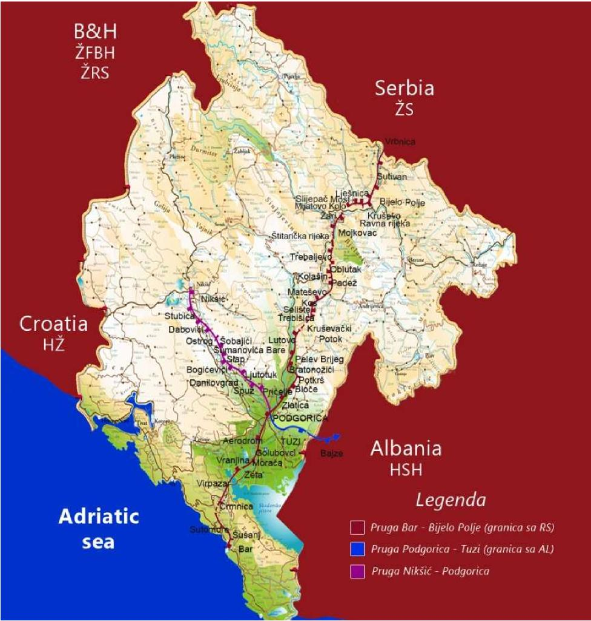

Annex 3. Stations and other official places on montenegrin railway network

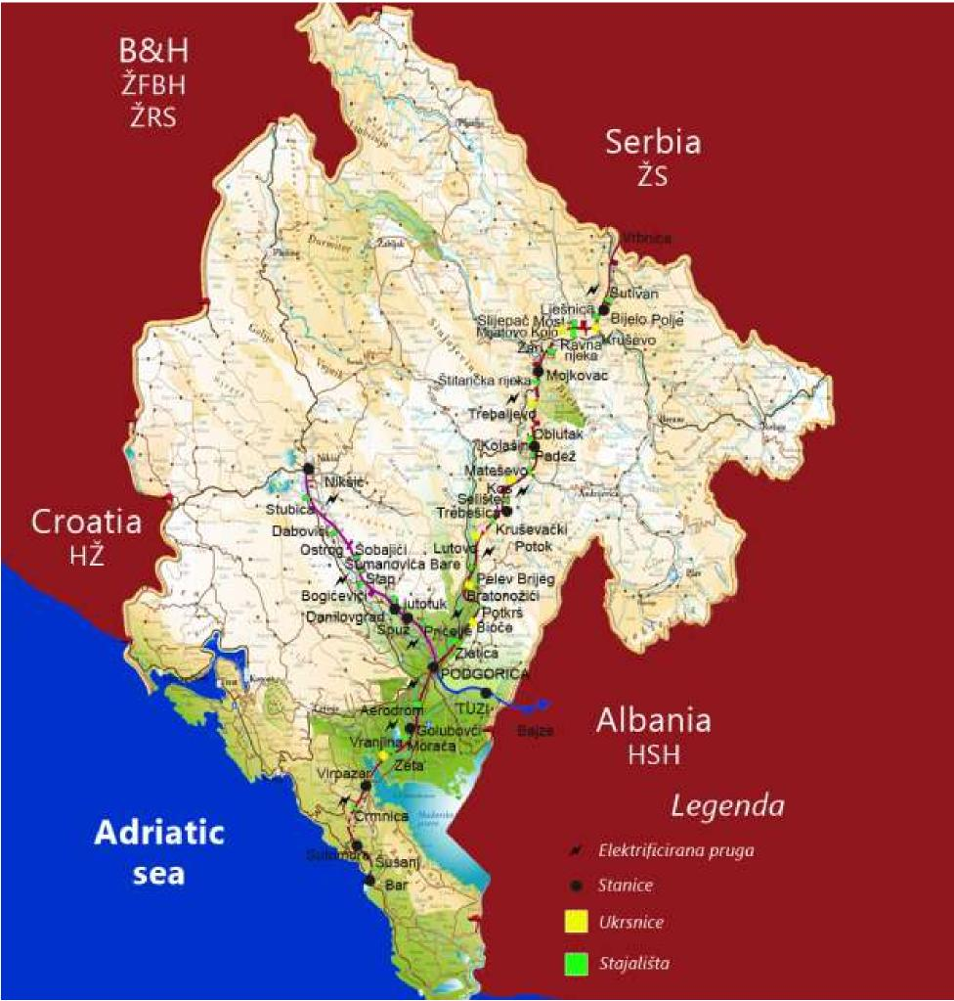

Annex 4. Distance between official places and the maximum allowed speed on line
Name of station / section | km position | Section  length | Interstation  distance | Maximum  allowed  speed
 |  | (m) | (m) | (km/h)
1 | 2 | 3 | 4 | 5
State border - Bijelo Polje - Bar
State border | 287+438,70 |  | 9.498,80
State border – Bijelo Polje |  | 9.498,80 |  | 80
Bijelo Polje | 296+937,50 |  |  | 80
Bijelo Polje - Lješnica |  | 2.930,50 | 24.401,21 | 80
Lješnica | 299+868 |  |  | 80
Lješnica - Kruševo |  | 4.369,00 |  | 80
Kruševo | 304+237 |  |  | 80
Kruševo - Ravna Rijeka |  | 4.093,00 |  | 80
Ravna Rijeka | 308+330 |  |  | 80
Ravna Rijeka - Slijepač Most |  | 2.140,00 |  | 80
Slijepač Most | 310+470 |  |  | 80
Slijepač Most - Mijatovo Kolo |  | 3.163,53 |  | 80
Mijatovo Kolo | 313+633,53 |  |  | 80
Mijatovo Kolo - Ţari |  | 2.966,47 |  | 80
Ţari | 316+600 |  |  | 80
Ţari - Mojkovac |  | 4.738,71 |  | 80
Mojkovac | 321+338,71 |  |  | 80
Mojkovac - Štitarička Rijeka |  | 3.077,29 | 19.311,26 | 80
Štitarička Rijeka | 324+416 |  |  | 80
Štitarička Rijeka - Trebaljevo |  | 6.699,46 |  | 80
Trebaljevo | 331+115,46 |  |  | 80
Trebaljevo - Oblutak |  | 3.684,54 |  | 80
Oblutak | 334+800 |  |  | 80
Oblutak - Kolašin |  | 5.849,97 |  | 80
Kolašin | 340+649,97 |  |  | 80
Kolašin - Padež |  | 3.190,03 | 18.145,28 | 50
Padež | 343+840 |  |  | 50
Padež - Mateševo |  | 3.310,00 |  | 50
Mateševo | 347+150 |  |  | 50
Mateševo - Kos |  | 4.317,75 |  | 50
Kos | 351+467,75 |  |  | 50
Kos - Selište |  | 2.542,25 |  | 50
Selište | 354+010 |  |  | 50
Selište - Trebešica |  | 4.785,25 |  | 50
Trebešica | 358+795,25 |  |  | 50
Trebešica - Kruševački Potok |  | 5.694,75 | 46.347,79 | 50
Kruševački Potok | 364+490 |  |  | 50
Kruševački Potok - Lutovo |  | 5.114,39 |  | 50
Lutovo | 369+604,39 |  |  | 50

Lutovo - Pelev Brijeg |  | 4.301,61 |  | 50
Pelev Brijeg | 373+906 |  |  | 50
Pelev Brijeg - Bratonožići |  | 5.204,50 |  | 50
Bratonožići | 379+110,50 |  |  | 50
Bratonožići - Podkrš |  | 4.469,50 |  | 60
Podkrš | 383+580 |  |  | 60
Podkrš - Bioče |  | 5.991,16 |  | 60
Bioče | 389+571,16 |  |  | 60
Bioče - Zlatica |  | 10.884,84 |  | 60
Zlatica | 400+456 |  |  | 60
Zlatica - Podgorica |  | 4.687,04 |  | 60
Podgorica | 405+143,04 |  |  | 70
Podgorica - Aerodrom |  | 7.936,96 | 10.686,46 | 70
Aerodrom | 413+080 |  |  | 70
Aerodrom - Golubovci |  | 2.749,50 |  | 70
Golubovci | 415+829,50 |  |  | 70
Golubovci - Morača |  | 3.299,50 | 18.290,50 | 70
Morača | 419+129 |  |  | 70
Morača - Zeta |  | 5.279,00 |  | 70
Zeta | 424+408 |  |  | 70
Zeta - Vranjina |  | 3.206,00 |  | 70
Vranjina | 427+614 |  |  | 70
Vranjina - Virpazar |  | 6.506,00 |  | 70
Virpazar | 434+120 |  |  | 70
Virpazar - Crmnica |  | 3.425,00 | 12.027,80 | 70
Crmnica | 437+545 |  |  | 70
Crmnica - Sutomore |  | 8.602,80 |  | 70
Sutomore | 446+147,8 |  |  | 70
Sutomore - Šušanj |  | 5.911,20 | 8.699,20 | 70
Šušanj | 452+059 |  |  | 70
Šušanj - Bar |  | 2.788,00 |  | 70
Bar | 454+847 |  |  | 70
Nikšić- Podgorica
Nikšić | 0+293 |  |  | 75
Nikšié - Stubica |  | 8.719,00 | 34.132,50 | 75
Stubica | 9+012 |  |  | 75
Stubica - Daboviéi |  | 5.428,26 |  | 75
Daboviéi | 14+440,26 |  |  | 75
Dabovići - Ostrog |  | 2.873,82 |  | 75
Ostrog | 17+314,08 |  |  | 75
Ostrog - Šobajiéi |  | 3.720,92 |  | 75
Šobajiéi | 21+035 |  |  | 75
Šobajići - Šumanovića Bare |  | 2.299,24 |  | 75
Šumanoviéa Bare | 23+334,24 |  |  | 75
Šumanoviéa Bare - Slap |  | 2.283,35 |  | 75
Slap | 25+617,59 |  |  | 75
Slap - Danilovgrad |  | 8.807,91 |  | 75
Danilovgrad | 34+425,50 |  |  | 75
Danilovgrad - Ljutotuk |  | 3.850,80 | 22.082,74 | 60

Ljutotuk | 38+276,30 |  |  | 60
Ljutotuk - Spuţ |  | 5.468,70 |  | 60
Spuţ | 43+745 |  |  | 60
Spuţ - Pričelje |  | 3.199,67 |  | 60
Pričelje | 46+944,867 |  |  | 60
Pričelje - Podgorica |  | 9.563,56 |  | 60
Podgorica | 56+508,434 |  |  | 60
Podgorica -Tuzi – State border
Podgorica | 0+000 |  |  | 70
Podgorica - Tuzi |  | 13.683,00 | 13.683,00 | 70
Tuzi | 13+683 |  |  | 70
Tuzi – State border |  | 11.057,59 | 11.057,59 | 70
State border | 24+740,59 |  |  | 70

Annex 5. The maximum allowed train length
Official places | Vehicular direction A → B |  | Vehicular direction B → A
 | (direction as per name of  line) |  | (direction opposite name of  line)
 | Maximum  allowed  train  length | The longest  train  acceptance  tracks | Maximum  allowed  train  length | The longest  train  acceptance  tracks
 | [ m ] |  | [ m ]
1 | 2 | 3 | 4 | 5
DG - Bijelo Polje - Bar
Bijelo Polje | 694 | 3. 4. and 5. | 694 | 3. 4. and 5.
Kruševo | 657 | 2. and 3. | 669 | 2. and 3.
Mijatovo Kolo | 553 | 2. and 3. | 556 | 2. and 3.
Mojkovac | 505 | 2. 3. and 4. | 506 | 2. , 3. and 4.
Trebaljevo | 573 | 1. and 2. | 572 | 1. and 2.
Kolašin | 601 | 3. and 4. | 601 | 3. and 4.
Kos | 592 | 2. and 3. | 594 | - and 3.
Trebešica | 578 | - and 4. | 577 | 3. and 4.
Lutovo | 532 | 2. and 3. | 532 | 2. and 3.
Bratonoţiéi | 508 | 2. and 3. | 509 | 2. and 3.
Bioče | 510 | 1. and 2. | 507 | 1. and 2.
Podgorica | 665 | 4. 5. 6. 7.and 8. | 635 | 3. 4. 5. 6.  7.and 8.
Golubovci | 589 | 2. 3. and 4. | 598 | 2. 3. and 4.
Zeta | 595 | 2. and 3. | 594 | 2. and 3.
Virpazar | 698 | 2. 3. and 4. | 687 | 2. 3. and 4.
Sutomore | 569 | 2. i 3. | 590 | 2. and 3.
Bar | 700 | 1. 2. and 3. | 700 | 1. 2. and 3.
Nikšić - Podgorica
Nikšić | 610 | 2. | 467 | 2.
Ostrog ( STO ) | 532 | 3. | 532 | 3.
Danilovgrad | 537 | 1.2.3. | 537 | 1.2.3.
Spuţ | 620 | 3. | 620 | 3.

Podgorica | 628 | 4. 5. 6. 7.and  8. | 632 | 3. 4. 5. 6.  7. and 8.
Podgorica Tuzi - DG
Podgorica | 665 | 4. 5. 6. 7.and  8. | 635 | 3. 4. 5. 6.  7. and 8.
Tuzi | 641 | 3. | 642 | 3.

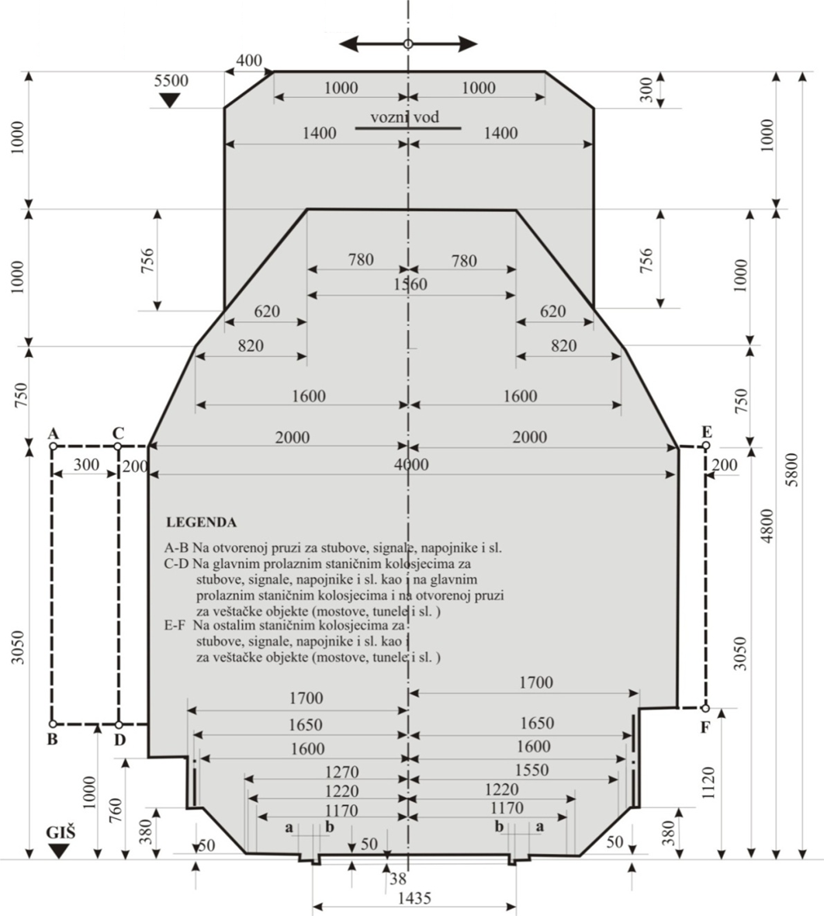
Annex 6. Gauge GB

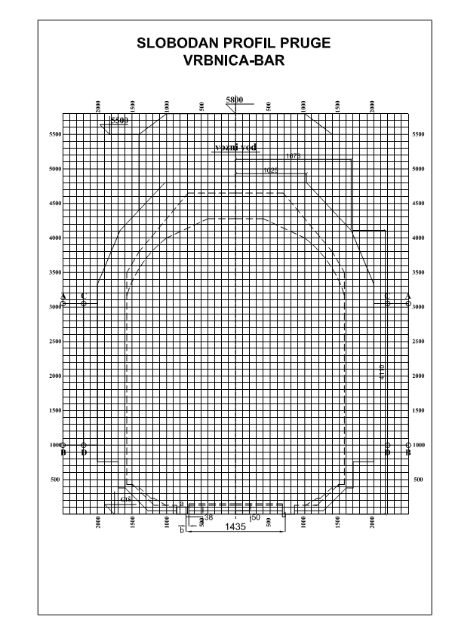

Prilog 7. The paramount gradients and line resistances

Route section | Vehicular distance A → B |  |  |  | Vehicular distance B → A
 | Paramount  gradient |  | Paramount  line  resistance  [ daN/t ] |  | Paramount  gradient |  | Paramount  line  resistance  [ daN/t ]
 | Incline  [~] | Decline  [~] |  |  | Incline  [ ~ ] | Decline  [ ~ ]
1 | 2 | 3 | 4 |  | 5 | 6 | 7
1. State border - Bijelo Polje - Bar
State border – Bijelo Polje | 8 | 5 | 8 | 5 |  | 8 | 5
Bijelo Polje - Kruševo | 18 | 6 | 19 | 6 |  | 18 | 7
Kruševo - Mijatovo Kolo | 18 | 0 | 19 | 0 |  | 18 | 0
Mijatovo Kolo - Mojkovac | 16 | 10 | 19 | 10 |  | 16 | 12
Mojkovac - Trebaljevo | 18 | 0 | 19 | 0 |  | 18 | 0
Trebaljevo - Kolašin | 17 | 2 | 18 | 2 |  | 17 | 3
Kolašin - Kos | 2 | 17 | 3 | 17 |  | 2 | 20
Kos - Trebešica | 0 | 24 | 0 | 24 |  | 0 | 26
Trebešica - Lutovo | 0 | 24 | 0 | 24 |  | 0 | 26
Lutovo - Bratonoţiéi | 0 | 24 | 0 | 24 |  | 0 | 26
Bratonožići - Bioče | 0 | 24 | 0 | 24 |  | 0 | 25
Bioče - Podgorica | 2 | 25 | 4 | 25 |  | 2 | 25
Podgorica - Golubovci | 0 | 6 | 0 | 6 |  | 0 | 6
Golubovci - Morača | 0 | 1 | 0 | 1 |  | 0 | 1
Morača - Zeta | 0 | 1 | 0 | 1 |  | 0 | 2
Zeta - Vranjina | 0 | 1 | 0 | 1 |  | 0 | 1
Vranjina - Virpazar | 1 | 2 | 2 | 2 |  | 1 | 3
Virpazar - Crmnica | 8 | 0 | 8 | 0 |  | 8 | 0
Crmnica - Sutomore | 4 | 3 | 5 | 3 |  | 4 | 4
Sutomore - Bar | 0 | 8 | 0 | 8 |  | 0 | 8
2. Nikšić - Podgorica
Nikšić – Ostrog | 0 | 3 | 0 | 3 |  | 0 | 3
Ostrog - Danilovgrad | 1 | 25 | 2 | 25 |  | 1 | 26
Danilovgrad - Spuž | 8 | 7 | 8 | 7 |  | 8 | 7
Spuž - Podgorica | 7 | 6 | 8 | 6 |  | 7 | 7
3. Podgorica – Tuzi – State border
Podgorica – Tuzi | 6 | 7 | 6 | 7 |  | 6 | 8
Tuzi – State border | 6 | 7 | 7 | 7 |  | 6 | 7

Annex 8. Electrification system

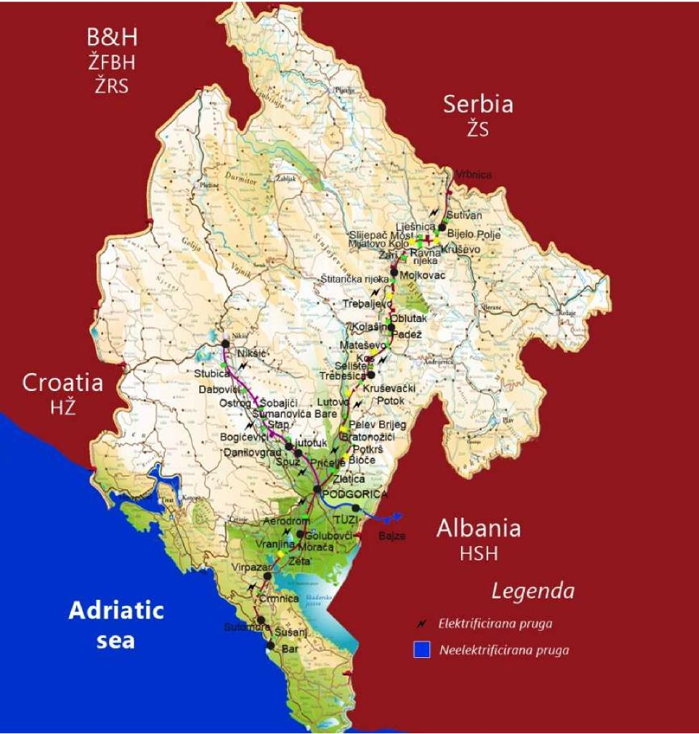

Annex 9. List of railroads eligible for management of hauled stock in owner administration
Railway line | Remark
Podgorica – Bijelo  Polje – state border  with Serbia and vice  versa | Motive power of freight train must have driver and assistant to driver
Podgorica – Nikšić and  vice versa | On the section of line Nikšić –  Danilovgrad and vice versa Motive power of freight train must have driver and assistant to driver
Bar – Podgorica and
vice versa
Podgorica – state
border with Albania
(Bajze) and vice versa

Annex 10. List of railroads eligible for management in owner administration
Motive power type | Vehicle type | Series of vehicle
Electrical | Locomotives | 441, 461
 | multiple - unit set | 412/416, CAF CIVITY  Other EMV adapted to  owner administration
Diesel | locomotives | 642, 643, 644¹, 661² i 744
1, ² Only if the train is pulled by shorter end forward

Annex 11. Types and routes of optical cables
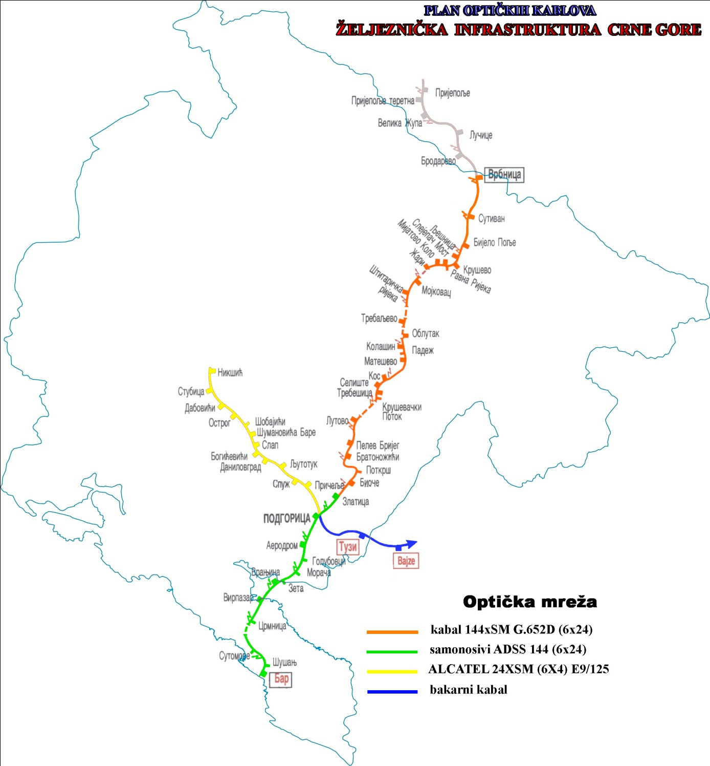

Annex 12. Review of Autostop devices along the railway line
Railway line | km position of initial balises  and signal marks | km position of initial balises  and signal marks
Bijelo Polje –Bar | km 295+215  Pau -92 | km 453+071  PFu-2
Bar – Bijelo Polje | km 455+430  FO -1 | km 299+065  PAu-91
Podgorica – Tuzi | km405+289  Ao -6 | km 12+000  PPu-92
Nikšié –Podgorica | km 1+348  Fu-91 | km 54+8  Pnu -94
Podgorica – Nikšié | km 45+408  PFu-91 | km 1+349  Au-91
Tuzi – Podgorica | km 15+120  PFu-91 | km 406+037  Au-93

65
Annex 13. Review of official places for acceptance and dispatching of passengers
Official place | Status | Supervision station
1 | 2 | 3
Bijelo Polje - Bar
Aerodrom | stop
Bar | station
Bijelo Polje | station
Bioče | Passing point | Podgorica
Bratonožići | Passing point | Trebešica
Crmnica | stajalište
Golubovci | station
Kolašin | station
Kos | Passing point | Kolašin
Kruševački Potok | stop
Kruševo | Passing point | Bijelo Polje
Lutovo | Passing point | Trebešica
Lješnica | stop
Mateševo | stajalište
Mijatovo Kolo | Passing point | Bijelo Polje
Mojkovac | station
Morača | stop
Oblutak | stop
Padež | stop
Pelev Brijeg | stop
Podgorica | station
Podkrš | stop
Ravna Rijeka | stop
Selište | stop
Slijepač Most | stop
Sutivan | stop
Sutomore | station
Štitarička Rijeka | stop
Šušanj | stop
Trebaljevo | Passing point | Mojkovac
Trebešica | station
Virpazar | station
Vranjina | stop
Zeta | Passing point | Virpazar
Zlatica | stop
Žari | stop
Nikšić - Podgorica
Nikšić | station
Stubica | stop
Dabovići | stop
Ostrog | Passing point | Nikšić
Šobajići | stop
Šumanovića bare | stop
Slap | stop
Danilovgrad | station
Ljutotuk | stop
Spuž | Passing point
Pričelje | stop
Podgorica | station

Annex 14. Review of freight car scales and measurer of loading gauge
Railway line | Station | Carrying  capacity of scale  (t) | Length of scale  (m) | Measurer of  loading gauge
Bar – Bijelo Polje | Bar | 80 t | 12 m | Exist
Bar – Bijelo Polje | Bar – I rayon grupa | 100 t | 20 m
Bar – Bijelo Polje | Bar – II rayon grupa | 100 t | 20 m
Bar – Bijelo Polje | Bar – III rayon grupa | 100 t | 20 m | Exist
Bar – Bijelo Polje | Podgorica | 80 t | 12 m | Exist
Bar – Bijelo Polje | Bijelo Polje | 100 t | 20 m | Exist
Nikšić – Podgorica | Nikšić | 100 t | 20 m | Exist
Podgorica - Tuzi | Tuzi | Do not exist | Do not exist | Exist

Annex 15. Review of freight platforms for loading and unloading
Official place | Type of  platform | Location/track | Dimensions  (GEãEv) | Material
Bar | side-loading  platform | Ia handling | 65/16,35/1,1 | concrete
Sutomore | side-loading  platform | I storage | 16/9,55/1,1 | concrete
Virpazar | side-loading  platform | I track | 20/12/1,1 | concrete
Golubovci | side-loading  platform | I track | 15,30/9,6/1,1 | concrete
Podgorica | side-loading  platform | 18 storage track | 151/15,20/1,1 | stone
Mojkovac | side-loading  platform | I track | 80/15/1,1 | concrete
Kolašin | side-loading  platform | I track | 42/9/1,1 | concrete
Bijelo Polje | side-loading  platform |  | 37/20/1,3 | concrete
Tuzi | side-loading  platform | I track | 40/15,2/1,1 | concrete
Nikšiá | side-loading  platform | I storage track | 27,7/9,5/1,1 | concrete
 | end-loading  platform | 15 tracks | 27,7/9,5/1,1 | concrete

Annex 16. Planned works for reconstruction and rehabilitation of the railway infrastructure
1) Railway line Belgrade- Bar
No | Project title | Completion  period | Planned  commenc  ement | Planned  line  closure | Planned  completion
1. | Replacement of signal and safety devices in station Podgorica  (works + supervision) | 12 months | III quarter of 2017 | 5^{h} | III quarter of 2018
2. | Rehabilitation of slopes  - km 369+424 - km 369+979  - km 373+344 - km 374+189  - km 375+386 - km 376+267  - km 377+069 - km 377+631  - km 378+176 - km 378+326  - km 378+524 - km 378+750 | 20 months(6 months designing + 14 months for works) | II quarter of 2018 | 4.5^{h} | IV quarter of  2019
3. | Rehabilitation of superstructure of railway section Kos - Trebešica (km 351+ 684.65 - km 357+951 )  (works + supervision) | 15 months | II quarter of 2018 | 5^{h} | III quarter of  2019
4. | Rehabilitation of 5 pre-stressed concrete bridges  - Bridge 40 (km 332+323,76)  - Bridge 42 (332+748,66)  - Bridge 47( 338+952,47)  - Bridge 52 (344+143,98)  - Bridge 53 (345+767,98)  (first priority group) | 12 months | II quarter of 2018 | 5^{h} | II quarter of 2019
5. | Rehabilitation of priority group of concrete bridges  (second priority group) | 12 months | III quarter of 2018 | 4-5^{h} | III quarter of 2019
6. | Rehabilitation of priority group of tunnels  (first priority group) | 12 months | II quarter of 2019 | 4-5^{h} | II quarter 2020

Annex 17. Time-limit for designing of annual timetable 2019/2020

Phase | Body | Deadline
Planning of the basic international train path | IM | 14.01.2019.
A regular deadline for submission of an application for the allocation of the route for the annual timetable | RU | 15.12.2018. - 08.04.2019.
Creating a draft Timetable | IM/RU | 09.04.2019.- 15.07.2019.
Issuance of the dreft of Timetable | IM | 16.07.2019.
Comments on the dreft Timetable | RU | 17.07.2019. – 16.08.2019.
Compliance procedure | IM/RU | 17.08.2019. – 03.09.2019.
Defining the timetable according to the requests received at regular intervals | IM | 04.09.2019.
Predaja zahtjeva za dodjelu trasa nakon redovnog roka | RU | 09.04.2019. – 14.10.2019.
Defining the Timetable according to the requests received after the regular deadline | IM | 08.11.2019.
Deadline for accepting the final bid for allocated capacities |  | 15.11.2019.
Timetable effectivness | IM | 15.12.2019.

Annex 17a. . Time–limit for changes and amendments of annual timetable 2019/2020
Date of submission of request  for changes and amendments of  annual timetable | Date of application of changes  and amendments of annual  timetable | Time-limit for  allocation  capacity
30.12.2019. | 03.02.2020. | 20 days prior to  changes and  amendments
24.02.2020. | 06.04.2020.
27.04.2020. | 14.06.2020.
13.07.2020. | 07.09.2020.
24.08.2020. | 05.10.2020.

Annex 18. Value of factor for special consignments (Fnp) For special consignments _{Fnp} is calculated as it follows:
Services | Fnp
Consent of the other RUs | 1,1
Allowable maximum speed train Vmax = 60km/h | 1,2
Starting and stopping the train must not be suddenly, and driving staff must be informed about it in the "General Order" | 1,2
Attendant of the consignment should be alert to personal safety when crossing the electrified railway line and hand them a statement given in annex I of the Ordinance 20 with proof of signature | 1,2
On tracks with the platforms to drive 20 km / h, the platforms without passengers, goods and  materials | 1,2
When controlling measures, responsible worker of services for maintaining the railway line  (railroad foreman, oficer for the substructure) | 1,3
Transport in regular freight trains | 1,3
Rail vehicles operating on its own wheels if they do not have a sign RIV or RIC, as well as vehicles that are not included in the roling stock of ŽICG (new cars, hauled locomotive and self-propelled and private cars) | 1,3
Goods which load units are connected in bundles (which can be deflected), for example: a round concrete steel and similar goods that exceeds the length of more than 36 m | 1,3
Shipments which length exceeding bogie car more than 6.5 m. In this case, the buffer wagons are added under the provisions of point 7.3. Annex II RIV (Volume 1) | 1,3
Prohibited the transport near loading ramp , near eaves and below the loading control profiles | 1,5
At stations, it must not be occupied adjoining rail tracks, at least 15 m from shunting limit signal | 1,5
Obliged grounding of the special consignment on electrified lines under the provisions of  Regulations 20 (Annex II) | 1,5
Throughout all stations , pass only on the main tracks | 1,5
Driving through the switche in the turn at a speed of Vmax = 20 km / h | 1,5
Transport of shipment is necessarily accompanied by an employee of technical academic profession in his section, he immediatelly checks the state of the shipment and, if necessary, he determines by himself an light drive in sharp curves, or via switches in turn position | 1,5
Consignment which dimensions are within the limits of the load profile of track, but do not meet the prescribed distance between loads (vehicle) and load profile of lines, determined by provision of Volumes 1 of Schedule II of the Rules RIV (Annex III of this Regulation) | 1,5
Cars with more than 8 axles when loaded, even if they have asign RIV | 1,5
Items that cannot be transported to the terminal stations without reloading, if individually weighing more than 25 tons, or loaded into a car with low floor | 1,5
Consignments on electrified lines cannot meet the required security clearances between the furthest parts of its mass and parts of catenary under voltage | 1,5

Load of rails, iron, steel, or similar things unconnected (non-deflected) length of over 36 m of loaded on two or more cars without trunnions (Regulations on loading the car, Volume 1, Appendix II of the Rules RIV) | 1,5
Shipments loaded onto two or more cars with trunnions that are not connected by clutches to the screw or by assisting cars, for example:  − rigid clutch,  − assisting cara that are connected by stiff clutch with loaded car and both from one side ,  and from the other side  − By means of load of suitable shape fixed to the trunnions so that it can transfer  towing forces and repulsive forces | 1,5

For other special consignments shall be concluded special agreements between ŽICG and operators, according to the criteria of the Ordinance 20 on the carriage of special shipments.

Annex 19. Review of tracks intended for side tracking of cars/sets

Station | Tracks on which is made charging for side tracking | Tracks on which is not made charging for side tracking
Bijelo Polje | 1, 2, 3, 4, 5 and 6 | 7
Podgorica | 1, 2, 3, 4, 5, 6, 7 and 8 | 9, 10, 11 and 12
Bar | 1, 2, 3, 4, 5, 6, 7, 8 and 9 | 10, 11, 12, 13 and 14
Nikšić | 1, 2, 3, 4, 5, 6 and 7 | 10 and12
Tuzi | 1, 2, 3 and 4 | 5
Annex 20. Review of primary causes of train delays
Primary causes of delay of the infrastructure manager (ŽICG)
No. |  | Title
 |  | Waiting for approval
 |  | Waiting in input signal
 |  | dispatch order
 |  | The delay caused by the fault of the employee that is employed in infrastructure manager
 |  | Reducing speed on-demand of infrastructure managers
 |  | Sending an order for train driver
 |  | Failure in the station SS device
 |  | Line closire by infratsructure manager
 |  | Defect on level crossing
 |  | Defect on the Overhead contact line
 |  | Defect on the telecommunication equipment
 |  | Prolonged halt of rail vehicles
 |  | Light drive
 |  | Unplanned closure of railway line
 |  | Rupture of rail
 |  | Track distortion
 |  | Technical irregularity of switches
 |  | Collision, overtaking and derailment of rolling stock
 |  | Failure of SS and TK equipment
 |  | The extension provided for line closure(over 30 minutes)
 |  | Avoided collision, overtaking and derailment of rolling stock

Annex 20. Review of primary causes of delay of rail carrier
Primary causes of delay of trains (railway transporter)
No. | Title
 | Increased frequency of passengers
 | Waiting for the train personnel of carrier
 | Waiting for a locomotive or motor rake of coaches
 | The delay caused by the fault of the employee in rail carrier
 | Cleaning of the wagon at the request of the railway transporter
 | Malfunction of wagon
 | Repair of wagon without dispatching
 | Malfunctioning of heating equipment
 | Changes in composition at the request of rail carrier
 | The intervention of law enforcement officers at the request of train crew
 | Waiting for shunting locomotive
 | Malfunction of traction vehicle / rake of coaches
 | Change of staff in rail transporter
 | Passing failure of locomotive / rake of coaches
 | Waiting for the formation of trains
 | Weighing
 | Transport of special consignment
 | Stopping to cool the brake shoes
 | Breakdown of motive power unit
 | break-down of wagon in train
21. | Interruption of aerial conductor of brake system
22. | The passage of the train next to signal that signals prohibition of further drive
23. | Not allowed passing of train through official place on which it has to stop

Annex 20. Review of primary causes of train delays
Primary causes of delays (external impacts)
No. | Title
 | State needs
The train received in delay from other railway
administration
Denied reception of train from the other railway
Administration
Waiting for the train crew of the other railway
administration
Train improperly composed by other railway
administration
Discomposition of defective wagons of other railway
administration
Discomposition of missend wagons of other railway
administration
 | Delay of employee of other railway administration
 | Slippage or landslide
 | Flood or torrent
 | Snowdrift, snow-slip and avalanches
 | Thick fog and rain
 | Fire in the area of railway line
 | Dropping out of the train
 | Hopping or jumping out of a train
Restraint of train by representatives of the Ministry of
internal affairs
 | Restraint of train by customs inspection bodies
 | Abuse of auxiliary brakes
 | Intervention of ambulance
 | Breakage of device on level crossing
 | Train stoning
 | Alienate of equipment or devices owned by infrastructure

Annex 20. Review of secondary causes of train delays
Secondary causes of train delays
No. | Title
 | Wait for crossing
 | Waiting due to overtaking
 | Waiting to check out
 | Waiting connection of the train in delay
 | Prolonged retention in the station due to waiting for the regular passage
 | Waiting for locomotives or rake of coaches from turn -round
 | Waiting for a train connection or at the request of the carrier
 | Waiting for the train personnel carriers from turn-round
 | The delay caused by the failure of the traction vehicle of other train
Connection of train (passenger or gross) by other railway
administration
 | Misuse of the emergency brake on the second train
 | The extraordinary event of the second train

Annex 20.The review of the causes of train delays caused by extraordinary events, which are in the process of investigation.
The causes of train delays caused by extraordinary events, which are in the
process of investigation
No. | Title
 | Collision
 | Overtaking
 | Derailment
 | Fire and explosion
 | Derailment and overtaking during maneuver
 | On level crossing is secured traffic by SS devices
 | On level crossing is secured traffic by road traffic signs
 | Extraordinary event on an open line
 | Extraordinary event in an official site
 | environmental incident
 | Other serious accidents
 | Breaking-loose of a train
 | Breakdown of overhead contact line
 | Avoidance of collision
 | Avoidance of overtaking
 | Switch section
 | Avoided extraordinary event on an open
 | Avoided extraordinary event in an official site
 | Avoided derailment
 | Other accidents avoided

